WEIGHT COACH APP
21CSC205P Database Management Systems

A MINI PROJECT REPORT

Submitted by
Sanchit Jaiswal [RA2411003011741]
Riya Raj [RA2411003011753]

Under the Guidance of
DR U KARTHIKEYAN
Assistant Professor, CTECH

in partial fulfillment of the requirements for the degree of

BACHELOR OF TECHNOLOGY

in


COMPUTER SCIENCE & ENGINEERING

DEPARTMENT OF COMPUTING TECHNOLOGY

SCHOOL OF COMPUTING

COLLEGE OF ENGINEERING AND TECHNOLOGY
SRM INSTITUTE OF SCIENCE AND TECHNOLOGY

KATTANKULATHUR- 603 203

MAY 2026



SRM INSTITUTE OF SCIENCE AND TECHNOLOGY KATTANKULATHUR – 603 203

BONAFIDE CERTIFICATE

Certified that Project report titled “ WEIGHT COACH APP ” is the bonafide work of “Sanchit Jaiswal[RA2411003011741], Riya Raj RA2411003011753]” who carried out the 21CSC205P Database Management Systems mini project work under my supervision.

COURSE FACULTY | HEAD OF THE DEPARMENT  Dr G. Niranjana
DR. U KARTHIKEYAN  Assistant Professor  Department of Computing Technologies | PROFESSOR AND HEAD  Department of Computing Technologies

ABSTRACT

This project focuses on designing and implementing a relational database system for an AI-powered Weight Coach App aimed at improving nutrition management and reducing food waste in everyday life. The system stores and manages data related to users, kitchen inventory, recipes, and meal consumption.
The application allows users to track ingredients, monitor expiration dates, and receive intelligent recipe recommendations based on available items. It also records meal logs and nutritional information to help users maintain a balanced diet and achieve their health goals.
A web-based interface is developed to enable users to manage their inventory, log meals, and view personalized insights. The system dynamically identifies expiring ingredients, suggests optimal meal plans, and generates shopping lists to minimize waste and improve efficiency.
The database is designed using proper normalization techniques to ensure data consistency, reduce redundancy, and optimize performance. Data visualization elements such as dashboards, charts, and progress indicators are used to present user activity, nutritional intake, and food usage trends effectively.
This project demonstrates how database systems combined with intelligent recommendations can promote healthier eating habits, efficient kitchen management, and sustainable food consumption.

TABLE OF CONTENTS

Chapter No. | Title | Page no.
0 | ABSTRACT | 3
1 | Problem Understanding, Identification of Entities and Relationships, Construction of DB using ER Model | 7
2 | Design of Relational Schemas, Creation of Database and Tables for their project | 23
3 | 3.1Writing queries based on the concepts of Aggregate functions, constraints, sets | 37
 | 3.2 Writing complex queries based on subqueries, joins and views | 41
 | 3.3 Writing complex queries based on the concepts of functions, Triggers, Cursors and Exception Handling | 43
4 | 4.1 Analysing the pitfalls, identifying the dependencies, and applying Normalizations- 1NF, 2NF, 3NF | 62
 | 4.2 Analysing the pitfalls, identifying the dependencies, and applying Normalizations- 4NF, 5NF | 63
5 | Implementation of concurrency control and recovery mechanisms. | 73
6 | Front-end And Back-End Implementation code | 84
7 | Results and Discussions | 123

LIST OF FIGURES

Figure No. | Name | Page no.
1.1 | ER Diagram of Weight Coach App | 16
2.1 | Relational Schema of Weight Coach App | 20
3 | Sample Output of Constraints and Queries
4 | Sample Output of Joins and Views
5 | Trigger and Cursor Execution Output

CHAPTER 1

PROBLEM UNDERSTANDING, IDENTIFICATION OF ENTITY AND RELATIONSHIPS, CONSTRUCTION OF DB USING ER MODEL FOR THE ‘WEIGHT COACH APP’
1.1 Introduction
In today’s modern lifestyle, maintaining a healthy diet and managing food consumption has become increasingly difficult. People often purchase groceries without proper planning, leading to food wastage and unhealthy eating habits. The Weight Coach App is an AI-powered nutrition and kitchen management system designed to help users track ingredients, reduce food waste, and maintain a healthy diet.
Unlike traditional calorie tracking apps, this system focuses on the entire kitchen ecosystem, starting from ingredient management to meal preparation. The application uses intelligent recommendations to suggest meals based on available ingredients, dietary preferences, and nutritional goals. This ensures efficient utilization of resources and promotes healthier eating habits.

1.2 Motivation
The motivation behind developing the Weight Coach App arises from several real-world challenges.
Food Waste: A significant amount of food is wasted daily due to poor inventory management and lack of awareness about expiration dates. This leads to economic loss and environmental damage.
Healthy Eating Challenges: Many individuals struggle to maintain a balanced diet due to lack of planning and knowledge about nutrition.
Decision Fatigue: Choosing what to cook daily becomes overwhelming, especially for students and working professionals.
Technology Gap: Existing applications focus only on calorie tracking after meals instead of helping users before cooking decisions.
This project aims to solve these issues by providing an intelligent system that integrates inventory management with personalized meal recommendations.

1.3 Scope
The scope of the Weight Coach App includes:
Ingredient Management: Users can store and manage ingredients along with quantity, unit, and expiration dates. The system maintains a structured inventory of items available in the kitchen, helping users keep track of stock levels and avoid over-purchasing. It also allows categorization of ingredients based on storage locations such as pantry, refrigerator, and freezer.
Recipe Suggestions: The system suggests recipes based on available ingredients. By analyzing the ingredients currently present in the user’s inventory, the application provides intelligent meal recommendations that minimize the need for additional purchases. It also considers user preferences, dietary restrictions, and nutritional goals while suggesting recipes.
Nutritional Tracking: The application tracks calorie intake and nutritional values for better health monitoring. It helps users understand their daily consumption of proteins, carbohydrates, fats, and other nutrients, thereby promoting a balanced diet and supporting fitness goals such as weight loss or muscle gain.

Waste Reduction: The system provides alerts for expiring ingredients to minimize food waste. Notifications are generated when items are close to their expiration date, encouraging users to utilize them in recipes before they spoil. This feature helps in saving money and contributes to environmental sustainability.

User Profiles: The application supports personalized user profiles that store dietary preferences, allergies, and health goals. Each user can customize their experience based on their requirements, enabling more accurate and relevant recommendations.

Shopping Assistance: The system can generate smart shopping lists based on missing ingredients required for selected recipes. This ensures efficient grocery planning and avoids unnecessary purchases, making the shopping process more organized and cost-effective.

Progress Monitoring: The application provides dashboards and reports to track user progress over time. It displays insights such as reduction in food waste, improvement in eating habits, and consistency in following dietary plans.

Integration Capabilities: The system is designed to support integration with external services such as fitness trackers, health monitoring devices, and online grocery platforms. This enhances functionality and provides a more comprehensive user experience.

Scalability and Flexibility: The system is scalable and can handle multiple users simultaneously. It is designed with a modular architecture, allowing future enhancements such as mobile application support, AI-based meal planning, and real-time notifications.

Future Enhancements: The application can be extended to include features such as voice-based interaction, barcode scanning for automatic ingredient entry, AI-based calorie estimation, and integration with smart kitchen appliances.
The system is scalable and can be extended to include mobile integration and real-time notifications.

1.4 Problem Statement
In today’s fast-paced lifestyle, individuals often struggle to efficiently manage their kitchen inventory and maintain a healthy and balanced diet. The lack of a centralized and intelligent system leads to several practical challenges that affect both health and resource utilization.
The major problems identified are as follows:
- Inefficient Kitchen Inventory Management:
Users often forget what ingredients they already have, leading to duplicate purchases or unused items.
- Food Wastage:
Ingredients frequently expire before being used due to lack of tracking and timely reminders, resulting in financial loss and environmental impact.
- Poor Meal Planning:
Without proper planning tools, users find it difficult to decide what to cook, leading to unhealthy or repetitive food choices.
- Lack of Personalized Recommendations:
Existing systems do not consider individual dietary preferences, allergies, or fitness goals while suggesting meals.
- Unhealthy Eating Habits:
Due to convenience and lack of guidance, users often rely on processed or fast food instead of preparing balanced meals.
- Absence of Nutritional Awareness:
Users are generally unaware of their daily nutritional intake, which can negatively impact their long-term health.
- Time Consumption and Decision Fatigue:
Deciding meals daily becomes time-consuming and mentally exhausting, especially for students and working professionals.

Therefore, there is a need for an intelligent and integrated system that:
- Tracks kitchen inventory in real-time
- Provides personalized meal recommendations based on available ingredients
- Alerts users about expiring items to reduce waste
- Monitors nutritional intake for healthier living
- Assists in efficient meal planning and decision-making
The proposed Weight Coach App aims to address these challenges by combining smart inventory management with AI-driven recommendations, ultimately promoting a healthier lifestyle and minimizing food waste.

1.5 Project Requirements
The successful development of the Weight Coach App requires a combination of functional and non-functional requirements to ensure efficiency, reliability, and user satisfaction. These requirements define how the system should operate and the standards it must meet.

Functional Requirements
Functional requirements describe the core features and operations of the system.
1. User Management System
- Users must be able to register with a unique email ID and password.
- Secure login and authentication mechanisms must be implemented.
- Users should be able to update their profile details such as name, dietary preferences, and health goals.
- The system must maintain user-specific data to provide personalized recommendations.
2. Ingredient Management System
- Users should be able to add, update, and delete ingredients in their inventory.
- Each ingredient must store details such as name, quantity, unit, expiration date, and storage location.
- The system should allow categorization of ingredients (e.g., vegetables, dairy, grains).
- Automatic tracking of ingredient usage and availability must be supported.
3. Recipe Recommendation System
- The system should suggest recipes based on available ingredients in the inventory.
- Recommendations must consider user preferences, allergies, and dietary restrictions.
- Recipes should include preparation steps, required ingredients, and nutritional information.
- The system should also suggest alternative recipes when some ingredients are missing.
4. Meal Tracking and Logging
- Users must be able to log meals consumed daily.
- The system should store meal history for future reference and analysis.
- Nutritional values such as calories, proteins, fats, and carbohydrates should be recorded.
- The application should provide summaries of daily, weekly, and monthly food intake.
5. Notification and Alert System
- The system must notify users about ingredients nearing expiration.
- Alerts should be generated for low-stock items.
- Notifications should also suggest recipes using expiring ingredients.
- Reminders for meal planning and dietary goals should be included.
6. Shopping List Generation
- The system should automatically generate shopping lists based on missing ingredients.
- Users should be able to modify and customize the generated lists.
- The feature should help in efficient and cost-effective grocery shopping.
7. Data Storage and Management
- All user, ingredient, recipe, and meal data must be stored in a structured database.
- Proper relationships between tables should be maintained using keys and constraints.
- Data should be retrievable efficiently using SQL queries.

Non-Functional Requirements
Non-functional requirements define the quality attributes and performance standards of the system.
1. Performance
- The system should provide fast response times for all operations.
- Database queries should be optimized for quick retrieval of data.
- The application must handle multiple users without performance degradation.
2. Security
- User authentication must be secure with encrypted passwords.
- Sensitive data should be protected using appropriate security measures.
- Unauthorized access to user data must be prevented.
3. Scalability
- The system should support a growing number of users and data.
- The database design must allow easy expansion without affecting performance.
- Future features such as mobile integration and AI enhancements should be supported.
4. Usability
- The application must have a simple and user-friendly interface.
- Navigation should be intuitive for users of all age groups.
- Clear instructions and feedback messages should be provided.
5. Reliability
- The system should function correctly without frequent failures.
- Data integrity must be maintained at all times.
- Backup and recovery mechanisms should be considered.
6. Maintainability
- The system should be easy to update and maintain.
- Code should be modular and well-structured for future improvements.
- Documentation should be available for developers and users.
7. Availability
- The system should be available for use at all times with minimal downtime.
- Proper error handling should ensure smooth operation even in case of failures.

Conclusion
The above requirements ensure that the Weight Coach App is not only functional but also efficient, secure, and scalable. By meeting these requirements, the system will provide a comprehensive solution for managing kitchen inventory, reducing food waste, and promoting healthy eating habits.

1.6 Identification of Entity and Relationships
In the Weight Coach App, the database is designed to efficiently manage user data, kitchen inventory, recipes, and meal tracking. The system is built using multiple entities that interact with each other through well-defined relationships to ensure data consistency and effective functionality.

Entities
1. User
The User entity represents individuals who use the application. It stores all personal and account-related information required for authentication and personalization.
- Attributes:
user_id (Primary Key), name, email, password, dietary_preferences, created_at
- Each user has a unique identity and can manage their own ingredients, recipes, and meal logs.

2. Ingredients
The Ingredients entity represents the items available in the user’s kitchen inventory.
- Attributes:
ingredient_id (Primary Key), user_id (Foreign Key), name, quantity, unit, expiration_date, location
- This entity helps track available items, their quantities, and expiry details to reduce food wastage.

3. Recipes
The Recipes entity stores information about various dishes that users can prepare.
- Attributes:
recipe_id (Primary Key), name, instructions, preparation_time, nutritional_info, difficulty_level
- It provides structured data about recipes and enables intelligent recommendations based on available ingredients.

4. Recipe_Ingredients
This is a junction entity used to represent the many-to-many relationship between recipes and ingredients.
- Attributes:
recipe_id (Foreign Key), ingredient_name, quantity, unit
- It defines which ingredients are required for each recipe and in what quantity.

5. Meal Logs
The Meal Logs entity records the meals consumed by users.
- Attributes:
log_id (Primary Key), user_id (Foreign Key), recipe_id (Foreign Key), consumed_date, rating
- This entity helps track eating habits and analyze user dietary patterns over time.

Relationships
1. User – Ingredients Relationship
- Type: One-to-Many (1:M)
- One user can have multiple ingredients in their inventory.
- Each ingredient belongs to exactly one user.
- This relationship helps in maintaining personalized kitchen inventories.

2. User – Meal Logs Relationship
- Type: One-to-Many (1:M)
- One user can log multiple meals.
- Each meal log entry is associated with one user.
- This allows tracking of individual eating habits over time.

3. Recipes – Ingredients Relationship
- Type: Many-to-Many (M:N)
- One recipe can require multiple ingredients.
- One ingredient can be used in multiple recipes.
- This relationship is implemented using the Recipe_Ingredients junction table.

4. Recipes – Meal Logs Relationship
- Type: One-to-Many (1:M)
- One recipe can appear in multiple meal logs.
- Each meal log references one specific recipe.
- This helps in tracking which recipes are consumed frequently.

1.7 Construction of DB Using ER Model for the ‘WEIGHT COACH APP’
The ER model represents relationships between users, ingredients, recipes, and meal logs. It ensures proper database structure and normalization.
The system maintains relationships such as:
- Users → Ingredients (1:M)
- Users → Meal Logs (1:M)
- Recipes ↔ Ingredients (M:N)
Figure 1.1: ER Diagram of Weight Coach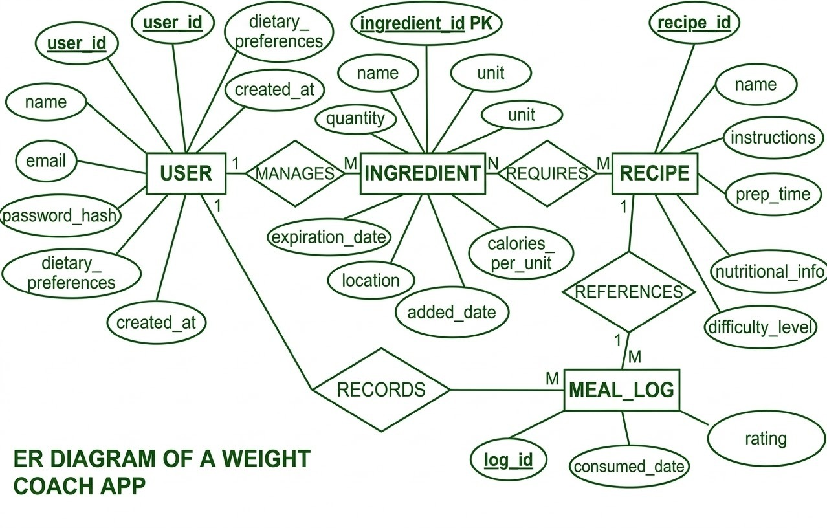

Entity | Description | Key Attributes
User | Registered user who manages diet and kitchen inventory | user_id (PK), name, email, password, dietary_preferences
Ingredients | Stores ingredients available in user's kitchen | ingredient_id (PK), user_id (FK), name, quantity, unit, expiration_date
Recipes | Stores recipe details and cooking instructions | recipe_id (PK), name, instructions, preparation_time, nutritional_info
Recipe_Ingredients | Junction table linking recipes and ingredients | recipe_id (FK), ingredient_name, quantity, unit
Meal Logs | Stores user meal consumption history | log_id (PK), user_id (FK), recipe_id (FK), consumed_date, rating

Table 1.1: Entity Definitions

Column | Data Type | Constraints | Description
user_id | INT | PRIMARY KEY | Unique user identifier
name | VARCHAR(100) | NOT NULL | User's full name
email | VARCHAR(255) | UNIQUE, NOT NULL | User's email address
password | VARCHAR(255) | NOT NULL | User password
dietary_preferences | VARCHAR(255) | NULL | User dietary preferences
created_at | TIMESTAMP | DEFAULT CURRENT_TIMESTAMP | Account creation timestamp

Table 1.2: User Schema

Column | Data Type | Constraints | Description
ingredient_id | INT | PRIMARY KEY | Unique ingredient identifier
user_id | INT | FK REFERENCES users(user_id) | Owner of the ingredient
name | VARCHAR(100) | NOT NULL | Ingredient name
quantity | DECIMAL(10,2) | NOT NULL | Quantity available
unit | VARCHAR(20) | NOT NULL | Measurement unit (kg, g, etc.)
expiration_date | DATE | NULL | Expiry date of ingredient
location | VARCHAR(50) | NULL | Storage location
calories_per_unit | INT | NULL | Calories per unit
added_date | TIMESTAMP | DEFAULT CURRENT_TIMESTAMP | Added date

Table 1.3: INGREDIENTS SCHEMA

Column | Data Type | Constraints | Description
recipe_id | INT | PRIMARY KEY | Unique recipe identifier
name | VARCHAR(200) | NOT NULL | Recipe name
instructions | TEXT | NOT NULL | Cooking instructions
prep_time | INT | NULL | Preparation time (minutes)
nutritional_info | VARCHAR(255) | NULL | Nutritional details
difficulty_level | VARCHAR(20) | NULL | Difficulty (Easy/Medium/Hard)

Table 1.4: RECIPES Schema

Column | Data Type | Constraints | Description
recipe_id | INT | FK REFERENCES recipes(recipe_id) | Linked recipe
ingredient_name | VARCHAR(100) | NOT NULL | Ingredient name
quantity | DECIMAL(10,2) | NOT NULL | Required quantity
unit | VARCHAR(20) | NOT NULL | Measurement unit
PRIMARY KEY | (recipe_id, ingredient_name) |  | Composite key

Table 1.5: RECIPE_INGREDIENTS SCHEMA

Column | Data Type | Constraints | Description
log_id | INT | PRIMARY KEY | Unique log identifier
user_id | INT | FK REFERENCES users(user_id) | User reference
recipe_id | INT | FK REFERENCES recipes(recipe_id) | Recipe consumed
consumed_date | DATE | NOT NULL | Date of meal
rating | INT | CHECK (rating BETWEEN 1 AND 5) | User rating
1.6 MEAL_LOGS SCHEMA

Chapter 2
Design of Relational Schemas, Creation of Database and Tables for CONTENT REPURPOSER

2.1 Relational Schema for Weight Coach App
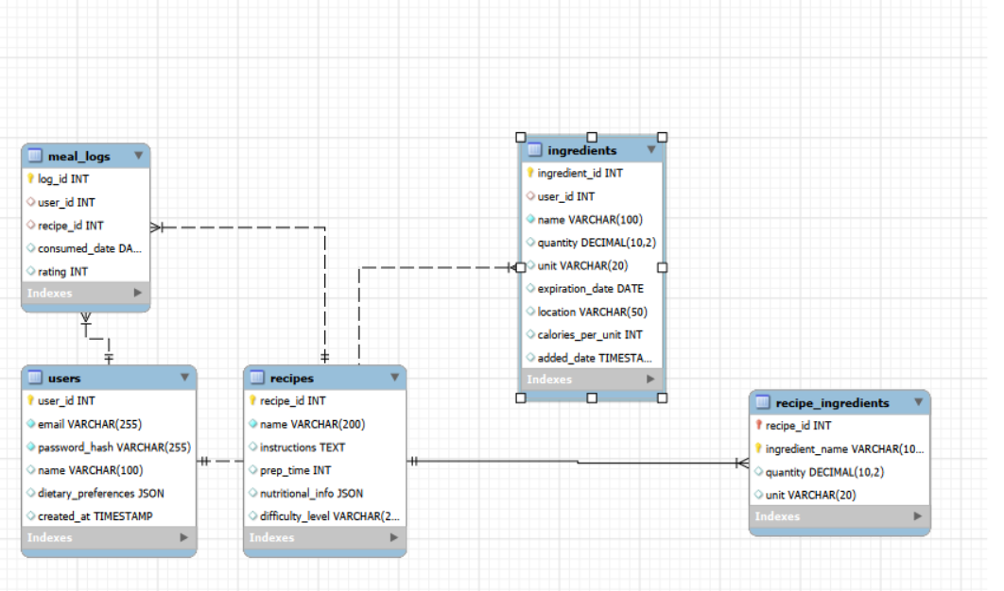
The figure 2.1 depicts the relational schema for CONTENT REPURPOSER .
The relational schema represents the logical structure of the database used in the Weight Coach App. It defines how data is organized into tables and how these tables are related to each other using keys and constraints. The schema ensures data consistency, integrity, and efficient retrieval of information.
The Weight Coach App database consists of the following main tables:
- Users
- Ingredients
- Recipes
- Recipe_Ingredients
- Meal_Logs
Each table is designed to store specific information and is connected through relationships using primary keys and foreign keys.

Explanation of Schema
The Users table stores all user-related information including login credentials and preferences. Each user is uniquely identified by a primary key user_id.
The Ingredients table maintains the inventory of items available in the user’s kitchen. It includes details such as quantity, unit, expiration date, and storage location. The user_id acts as a foreign key linking ingredients to a specific user.
The Recipes table stores information about different dishes, including instructions, preparation time, and nutritional values.
The Recipe_Ingredients table acts as a junction table that establishes a many-to-many relationship between recipes and ingredients. It specifies which ingredients are required for each recipe.
The Meal_Logs table records the meals consumed by users along with the date and user ratings. This helps in tracking dietary habits and analyzing user behavior.

Relationships in Schema
- One User → Many Ingredients (1:M)
- One User → Many Meal Logs (1:M)
- One Recipe → Many Meal Logs (1:M)
- Many Recipes ↔ Many Ingredients (M:N via Recipe_Ingredients)

2.2 Description of Tables
Table 2.21: users
Purpose: Stores registered user profiles and authentication credentials.
Column | Data Type | Size | Constraints | Description
ingredient_id | INT | - | PRIMARY KEY | Unique ingredient identifier
user_id | INT | - | FK → users(user_id) ON DELETE CASCADE | Owner of ingredient
name | VARCHAR | 100 | NOT NULL | Ingredient name
quantity | DECIMAL | (10,2) | NOT NULL | Available quantity
unit | VARCHAR | 20 | NOT NULL | Unit (kg, g, etc.)
expiration_date | DATE | - | NULL | Expiry date
location | VARCHAR | 50 | NULL | Storage location
calories_per_unit | INT | - | NULL | Calories per unit
added_date | TIMESTAMP | - | DEFAULT CURRENT_TIMESTAMP | Date added

Table 2.22: contents
Purpose: Stores original long-form content submitted for repurposing.

Column | Data Type | Size | Constraints | Description
recipe_id | INT | - | PRIMARY KEY | Unique recipe identifier
name | VARCHAR | 200 | NOT NULL | Recipe name
instructions | TEXT | - | NOT NULL | Cooking instructions
prep_time | INT | - | NULL | Preparation time
nutritional_info | VARCHAR | 255 | NULL | Nutrition details
difficulty_level | VARCHAR | 20 | NULL | Difficulty level

Table 2.23: repurpose_jobs
Purpose: Tracks each content transformation task through its lifecycle.
Column | Data Type | Size | Constraints | Description
recipe_id | INT | - | FK → recipes(recipe_id) | Linked recipe
ingredient_name | VARCHAR | 100 | NOT NULL | Ingredient name
quantity | DECIMAL | (10,2) | NOT NULL | Required quantity
unit | VARCHAR | 20 | NOT NULL | Measurement unit
PRIMARY KEY | - | - | (recipe_id, ingredient_name) | Composite key

Table 2.24: generated_outputs
Purpose: Stores AI-generated platform-specific content outputs.

Column | Data Type | Size | Constraints | Description
log_id | INT | - | PRIMARY KEY | Unique log identifier
user_id | INT | - | FK → users(user_id) | User reference
recipe_id | INT | - | FK → recipes(recipe_id) | Recipe consumed
consumed_date | DATE | - | NOT NULL | Date of meal
rating | INT | - | CHECK (rating BETWEEN 1 AND 5) | User rating

2.3 Creation of Database and Tables – DDL Commands
The database for the Weight Coach App is designed to efficiently manage user information, kitchen inventory, recipes, and meal tracking. The system uses Data Definition Language (DDL) commands to create the database structure, including tables, constraints, and relationships.
The database ensures data integrity, consistency, and proper relationships between entities using primary keys, foreign keys, and constraints. Each table is carefully designed to represent a real-world component of the system.

Database Creation
The first step is to create the database that will store all the application data:
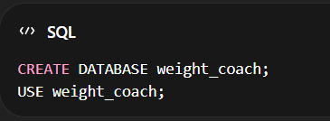
This database acts as the central storage for all user, ingredient, recipe, and meal-related data.

Table Creation
1. Users Table
The users table stores all registered user details, including authentication and preferences.
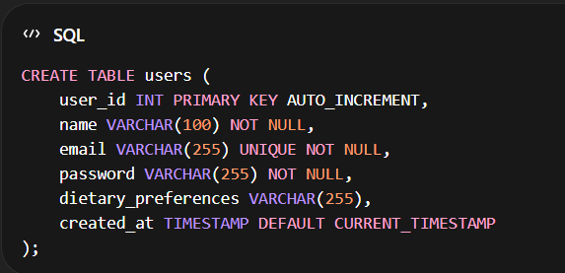\

2. Ingredients Table
The ingredients table maintains the inventory of items available in a user’s kitchen.
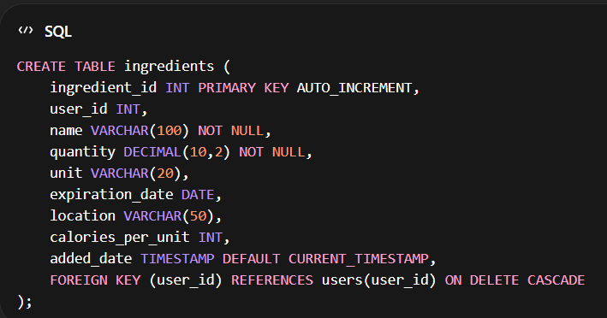

3. Recipes Table
The recipes table stores details about various recipes.
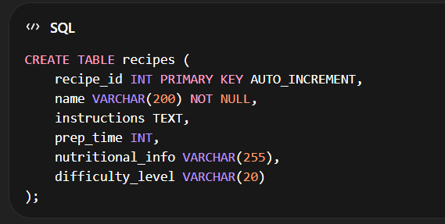\

4. Recipe_Ingredients Table
This table acts as a junction table linking recipes and ingredients.
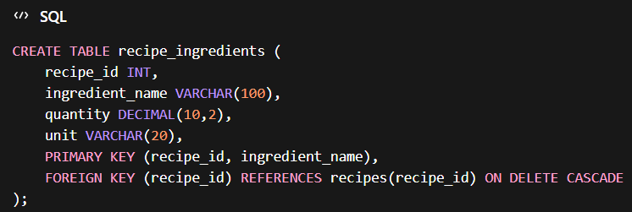
5. Meal Logs Table
The meal_logs table stores records of meals consumed by users.
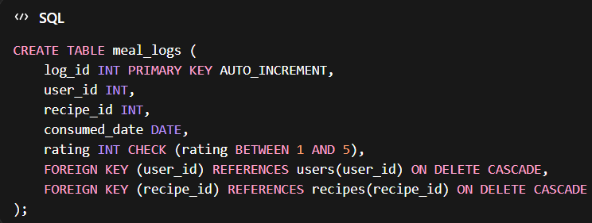

2.4 Insertion of tuples into the table – DML commands
Insert SQL (for all tables)

Users Table (20 Entries)
INSERT INTO users (user_id, name, email, password, dietary_preferences, created_at) VALUES
(1, 'Sanchit Jaiswal', 'sanchit@gmail.com', 'pass1', 'Vegetarian', '2026-01-01 09:00:00'),
(2, 'Riya Raj', 'riya@gmail.com', 'pass2', 'Non-Vegetarian', '2026-01-02 10:15:00'),
(3, 'Aman Verma', 'aman@gmail.com', 'pass3', 'Vegan', '2026-01-03 11:30:00'),
(4, 'Sneha Gupta', 'sneha@gmail.com', 'pass4', 'Vegetarian', '2026-01-04 14:00:00'),
(5, 'Rahul Sharma', 'rahul@gmail.com', 'pass5', 'Non-Vegetarian', '2026-01-05 08:45:00'),
(6, 'Ananya Singh', 'ananya@gmail.com', 'pass6', 'Vegan', '2026-01-06 16:20:00'),
(7, 'Karan Mehta', 'karan@gmail.com', 'pass7', 'Vegetarian', '2026-01-07 12:00:00'),
(8, 'Meera Nair', 'meera@gmail.com', 'pass8', 'Non-Vegetarian', '2026-01-08 09:30:00'),
(9, 'Arjun Reddy', 'arjun@gmail.com', 'pass9', 'Vegan', '2026-01-09 13:45:00'),
(10, 'Divya Iyer', 'divya@gmail.com', 'pass10', 'Vegetarian', '2026-01-10 10:00:00'),
(11, 'Amit Kumar', 'amit@gmail.com', 'pass11', 'Non-Vegetarian', '2026-01-11 15:30:00'),
(12, 'Roshni Das', 'roshni@gmail.com', 'pass12', 'Vegetarian', '2026-01-12 08:00:00'),
(13, 'Siddharth Rao', 'sid@gmail.com', 'pass13', 'Vegan', '2026-01-13 11:15:00'),
(14, 'Pooja Mehta', 'pooja@gmail.com', 'pass14', 'Vegetarian', '2026-01-14 14:30:00'),
(15, 'Rohit Kumar', 'rohit@gmail.com', 'pass15', 'Non-Vegetarian', '2026-01-15 09:00:00'),
(16, 'Kavya Bhat', 'kavya@gmail.com', 'pass16', 'Vegetarian', '2026-01-16 16:45:00'),
(17, 'Aditya Saxena', 'adi@gmail.com', 'pass17', 'Vegan', '2026-01-17 12:30:00'),
(18, 'Neha Tiwari', 'neha@gmail.com', 'pass18', 'Vegetarian', '2026-01-18 10:00:00'),
(19, 'Manish Dubey', 'manish@gmail.com', 'pass19', 'Non-Vegetarian', '2026-01-19 08:15:00'),
(20, 'Shruti Kapoor', 'shruti@gmail.com', 'pass20', 'Vegetarian', '2026-01-20 14:00:00');

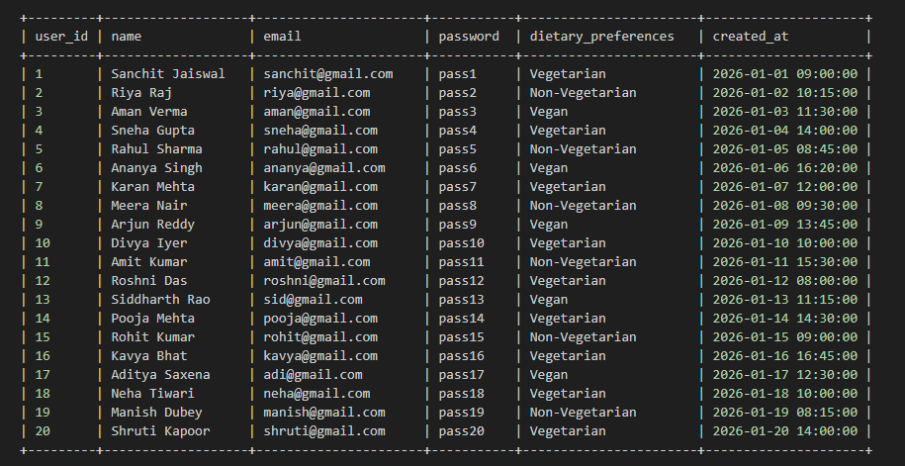

Ingredients Table (20 Entries)
INSERT INTO ingredients (ingredient_id, user_id, name, quantity, unit, expiration_date, location, calories_per_unit) VALUES
(1,1,'Tomato',2,'kg','2026-02-01','Fridge',18),
(2,1,'Potato',5,'kg','2026-03-01','Pantry',77),
(3,2,'Milk',1,'litre','2026-01-25','Fridge',42),
(4,2,'Eggs',12,'pieces','2026-02-10','Fridge',155),
(5,3,'Rice',10,'kg','2026-06-01','Pantry',130),
(6,3,'Dal',3,'kg','2026-05-01','Pantry',120),
(7,4,'Onion',2,'kg','2026-02-15','Pantry',40),
(8,5,'Chicken',1,'kg','2026-01-22','Freezer',239),
(9,6,'Paneer',500,'g','2026-01-28','Fridge',265),
(10,7,'Carrot',1,'kg','2026-02-05','Fridge',41),
(11,8,'Spinach',500,'g','2026-01-23','Fridge',23),
(12,9,'Bread',2,'packs','2026-01-21','Pantry',265),
(13,10,'Butter',200,'g','2026-03-01','Fridge',717),
(14,11,'Cheese',300,'g','2026-02-20','Fridge',402),
(15,12,'Apple',6,'pieces','2026-02-01','Fridge',52),
(16,13,'Banana',6,'pieces','2026-01-25','Fridge',89),
(17,14,'Oil',1,'litre','2026-06-01','Pantry',884),
(18,15,'Salt',1,'kg','2027-01-01','Pantry',0),
(20,17,'Flour',5,'kg','2026-05-01','Pantry',364); 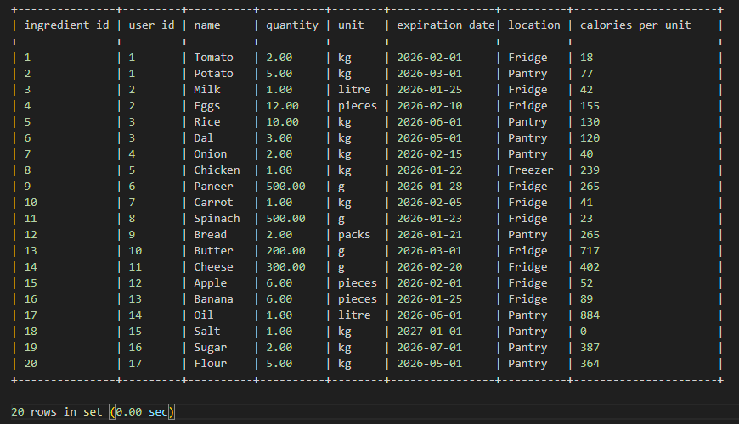
Recipes Table (10 Entries)
INSERT INTO recipes (recipe_id, name, instructions, prep_time, nutritional_info, difficulty_level) VALUES
(1,'Paneer Butter Masala','Cook paneer with gravy',30,'High Protein','Medium'),
(2,'Chicken Curry','Cook chicken with spices',40,'High Protein','Medium'),
(3,'Veg Salad','Mix vegetables',10,'Low Calorie','Easy'),
(4,'Omelette','Cook eggs',10,'Protein Rich','Easy'),
(5,'Rice and Dal','Boil rice and dal',25,'Balanced','Easy'),
(6,'Grilled Chicken','Grill chicken',35,'High Protein','Medium'),
(7,'Fruit Salad','Mix fruits',10,'Healthy','Easy'),
(8,'Paratha','Cook flour dough',20,'Carbs','Medium'),
(9,'Sandwich','Assemble bread and veggies',10,'Quick Meal','Easy'),
(10,'Pasta','Cook pasta with sauce',30,'Carbs','Medium');

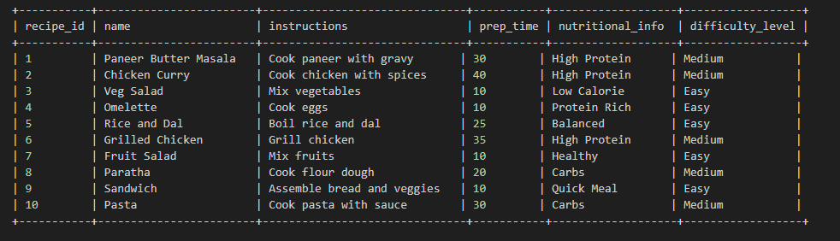

Meal Logs Table (10 Entries)
INSERT INTO meal_logs (log_id, user_id, recipe_id, consumed_date, rating) VALUES
(1,1,1,'2026-01-10',5),
(2,2,2,'2026-01-11',4),
(3,3,3,'2026-01-12',5),
(4,4,4,'2026-01-13',3),
(5,5,5,'2026-01-14',4),
(6,6,6,'2026-01-15',5),
(7,7,7,'2026-01-16',4),
(8,8,8,'2026-01-17',3),
(9,9,9,'2026-01-18',5),
(10,10,10,'2026-01-19',4);

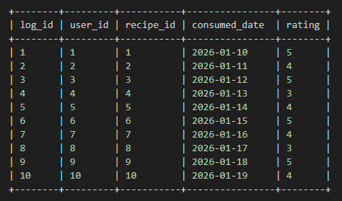

CHAPTER 3
Complex queries based on the concepts of constraints, sets, joins, views, Triggers and Cursors.

  - Adding Constraints and queries based on constraints
Complex Queries Based on the Concepts of Constraints, Sets, Joins, Views, Triggers and Cursors

Question 1: Ensure unique email and valid user data

SQL Statement:
CREATE TABLE users (
user_id INT AUTO_INCREMENT PRIMARY KEY,
email VARCHAR(255) UNIQUE NOT NULL,
password_hash VARCHAR(255) NOT NULL,
name VARCHAR(100),
dietary_preferences JSON,
created_at TIMESTAMP DEFAULT CURRENT_TIMESTAMP
);

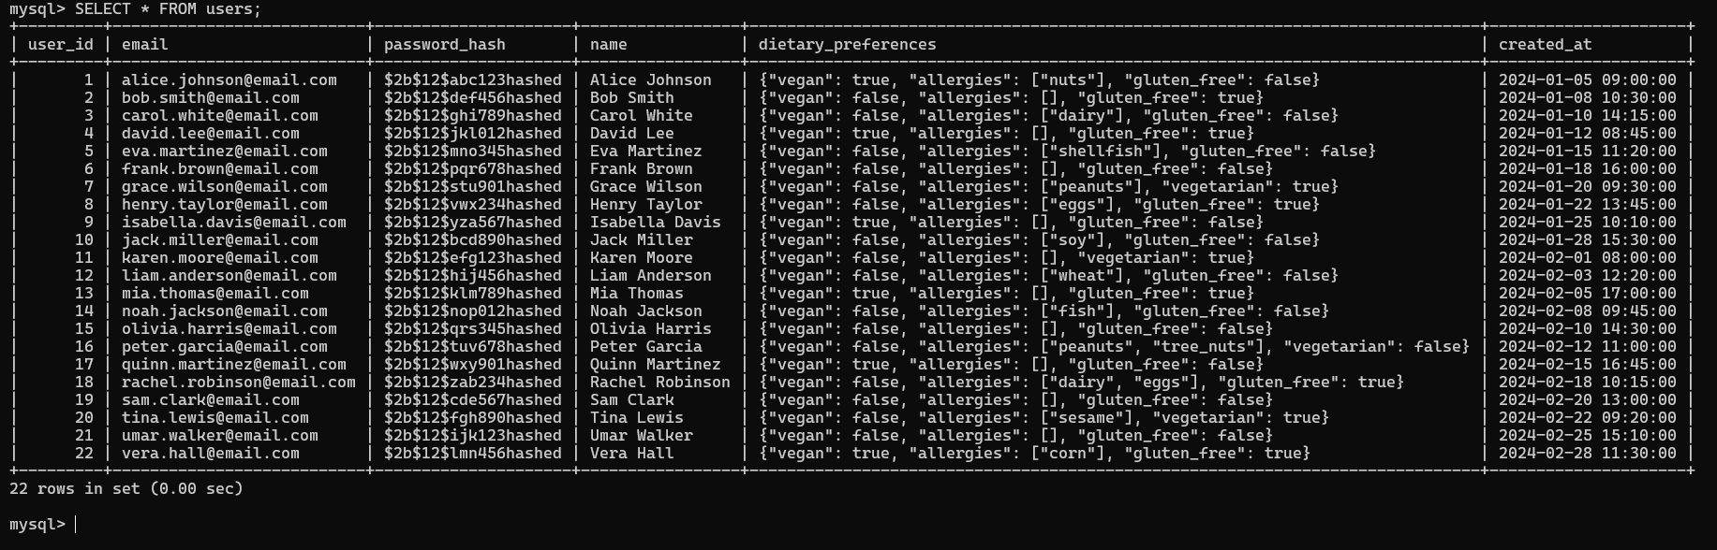

Question 2: Restrict rating between 1 and 5

SQL Statement:
CREATE TABLE meal_logs (
log_id INT AUTO_INCREMENT PRIMARY KEY,
user_id INT,
recipe_id INT,
consumed_date DATE,
rating INT CHECK (rating BETWEEN 1 AND 5),
FOREIGN KEY (user_id) REFERENCES users(user_id) ON DELETE CASCADE,
FOREIGN KEY (recipe_id) REFERENCES recipes(recipe_id) ON DELETE SET NULL
);

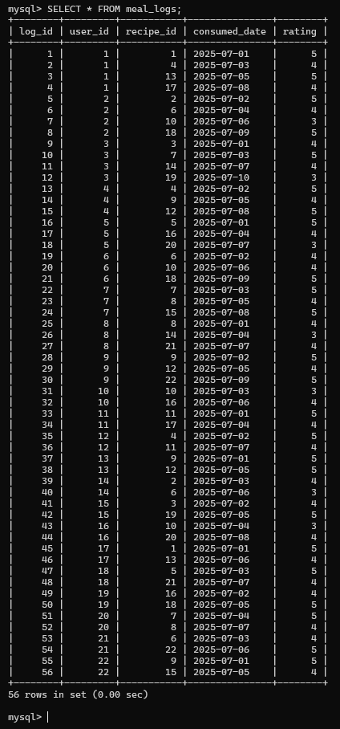

Question 3: Find ingredients expiring soon (next 3 days)

SQL Statement:
SELECT name, expiration_date
FROM ingredients
WHERE expiration_date <= DATE_ADD(CURDATE(), INTERVAL 3 DAY);

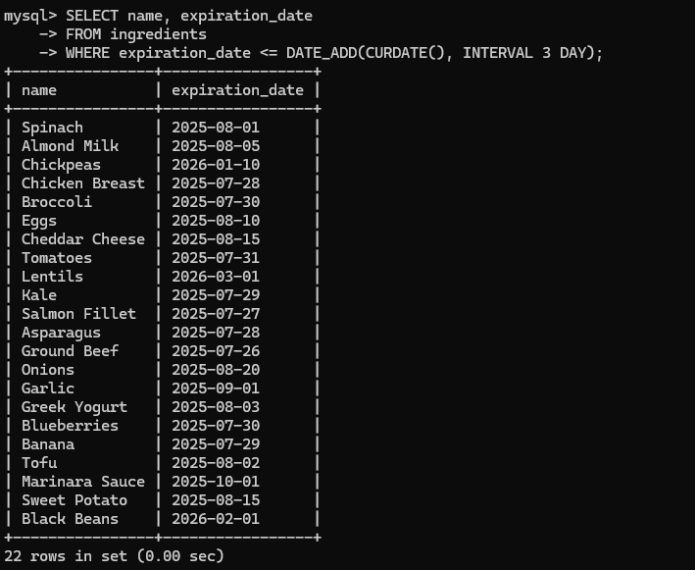

Question 4: Get recipes with their ingredients

SQL Statement:
SELECT r.name AS recipe, ri.ingredient_name
FROM recipes r
JOIN recipe_ingredients ri
ON r.recipe_id = ri.recipe_id;

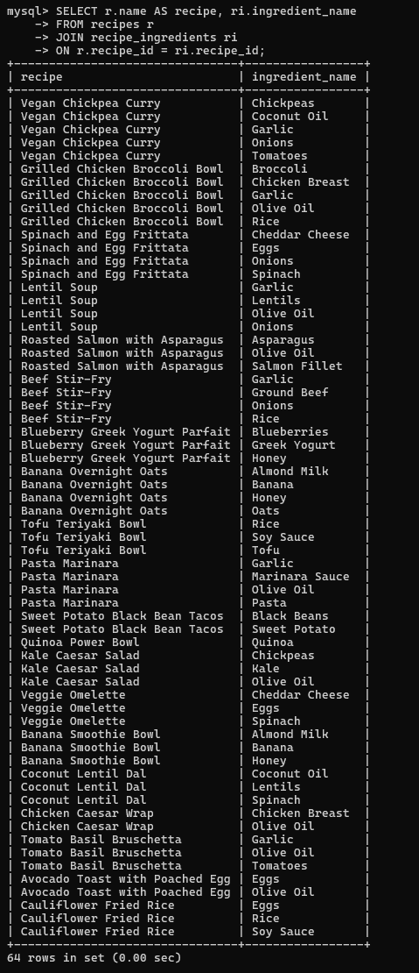

  - Queries based on Aggregate Functions

Question 1: Count total number of users

SQL Statement:
SELECT COUNT(*) AS total_users
FROM users;
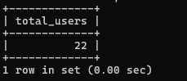

Question 2: Find total number of ingredients per user

SQL Statement:
SELECT user_id, COUNT(*) AS total_ingredients
FROM ingredients
GROUP BY user_id;
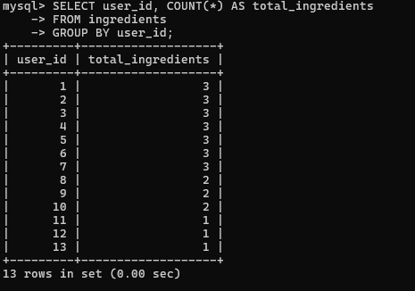

Question 3: Find total calories available in inventory

SQL Statement:
SELECT SUM(quantity * calories_per_unit) AS total_calories
FROM ingredients;
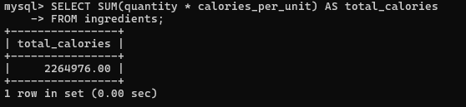

  - Complex queries based on Sets

Question 1: Find common ingredients in both inventory and recipes (INTERSECT)

SQL Statement:
SELECT DISTINCT i.name
FROM ingredients i
INNER JOIN recipe_ingredients ri
ON i.name = ri.ingredient_name;
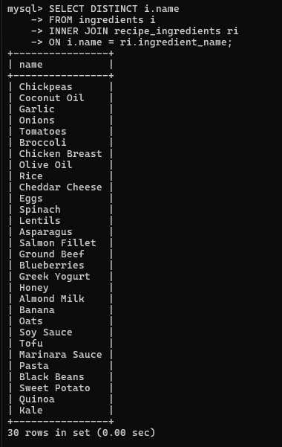

Question 2: Find ingredients in inventory but NOT used in any recipe (EXCEPT)

SQL Statement:

SELECT DISTINCT i.name

FROM ingredients i

LEFT JOIN recipe_ingredients ri

ON i.name = ri.ingredient_name

WHERE ri.ingredient_name IS NULL;

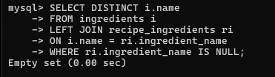

Question 3: Get all unique ingredient names used in recipes and inventory (UNION)

SQL Statement:

SELECT name AS item_name FROM ingredients
UNION
SELECT ingredient_name FROM recipe_ingredients;
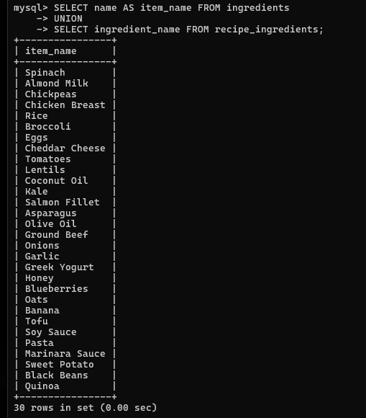

  - Complex queries based on Subqueries

Question 1 Find users who have not logged any meals

SQL Statement:
SELECT name
FROM users
WHERE user_id NOT IN (
SELECT user_id FROM meal_logs
);
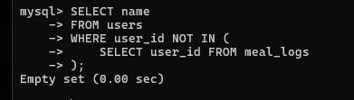

Question 2: Find recipes that require ingredients available in inventory

SQL Statement:
SELECT DISTINCT recipe_id
FROM recipe_ingredients
WHERE ingredient_name IN (
SELECT name FROM ingredients
);
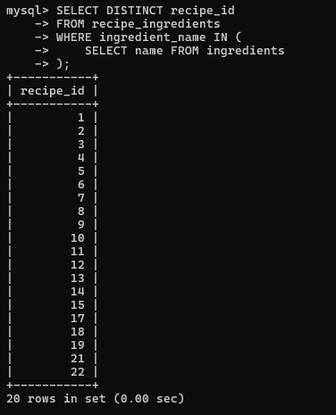

Question 3: Find highest rated meal

SQL Statement:
SELECT *
FROM meal_logs
WHERE rating = (
SELECT MAX(rating) FROM meal_logs
);
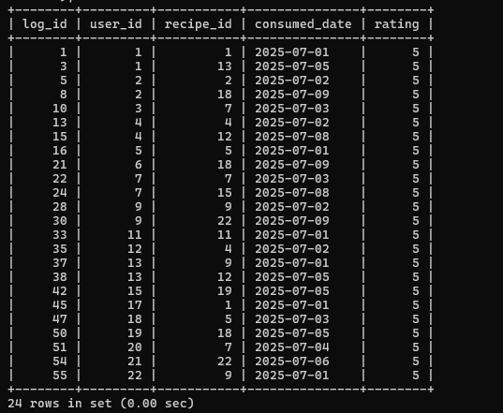

3.5 Complex Queries Based on Joins

Question 1: Get users and their meals (including users with no meals)

SQL Statement:
SELECT u.name, m.recipe_id
FROM users u
LEFT JOIN meal_logs m
ON u.user_id = m.user_id;
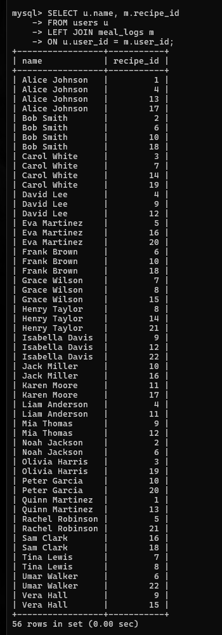

Question 2: Find ingredients and recipes they are used in

SQL Statement:
SELECT i.name AS ingredient, r.name AS recipe
FROM ingredients i
JOIN recipe_ingredients ri
ON i.name = ri.ingredient_name
JOIN recipes r
ON ri.recipe_id = r.recipe_id;
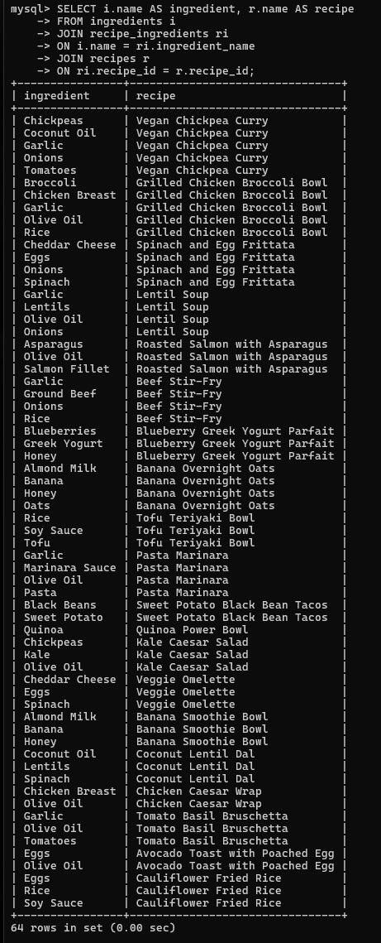

Question 3: Get recipes that can be made using available ingredients

SQL Statement:
SELECT DISTINCT r.name
FROM recipes r
JOIN recipe_ingredients ri ON r.recipe_id = ri.recipe_id
JOIN ingredients i ON ri.ingredient_name = i.name;

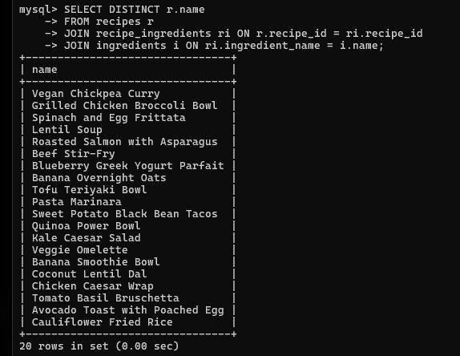

3.6 Complex queries based on views

Question 1: Create a view for recipes with ingredients

SQL Statement:
CREATE VIEW recipe_details_view AS
SELECT r.name AS recipe, ri.ingredient_name, ri.quantity
FROM recipes r
JOIN recipe_ingredients ri
ON r.recipe_id = ri.recipe_id;

-- Verify:
SELECT * FROM recipe_details_view;

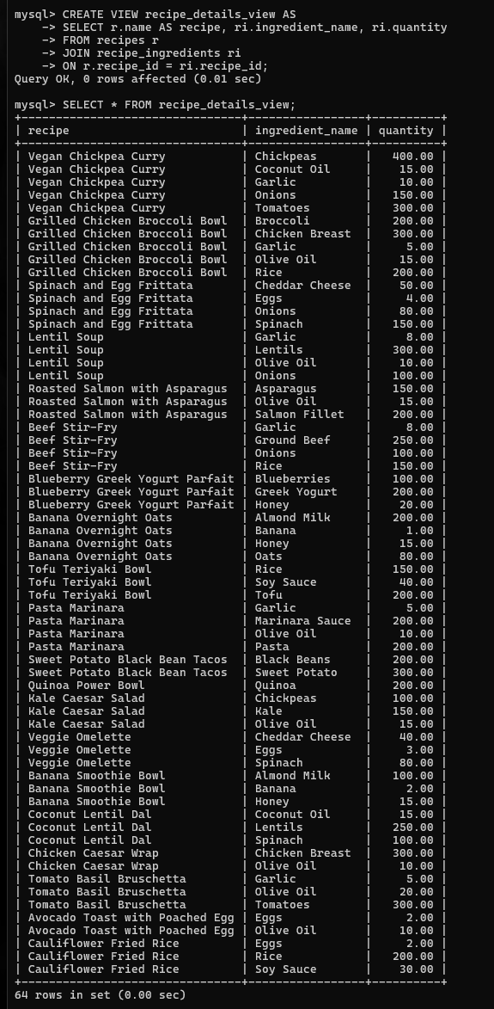

Question 2: View for expiring ingredients

SQL Statement:

CREATE VIEW expiring_ingredients_view AS

SELECT name, expiration_date

FROM ingredients

WHERE expiration_date <= DATE_ADD(CURDATE(), INTERVAL 3 DAY);

Verify:
SELECT * FROM expiring_ingredients_view;

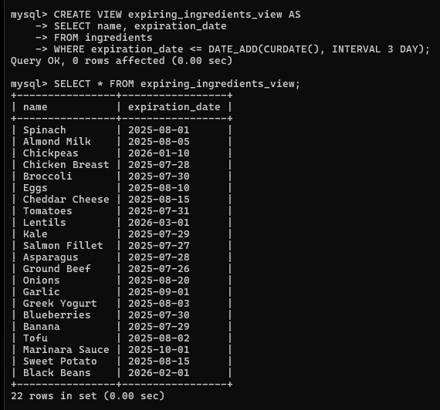

Question 3: View for user meal count

SQL Statement:

CREATE VIEW user_meal_count_view AS
SELECT u.name, COUNT(m.log_id) AS total_meals
FROM users u
LEFT JOIN meal_logs m
ON u.user_id = m.user_id
GROUP BY u.name;

Verify:
SELECT * FROM user_meal_count_view;

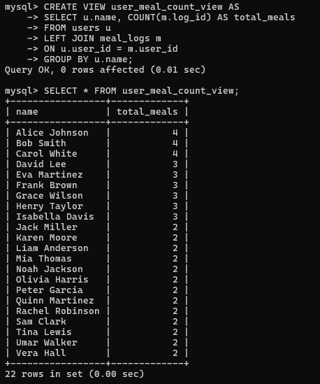

3.7 Complex queries based on Triggers

Question 1: Automatically set default rating if NULL

SQL Statement:

DELIMITER //

CREATE TRIGGER set_default_rating

BEFORE INSERT ON meal_logs

FOR EACH ROW

BEGIN

IF NEW.rating IS NULL THEN

SET NEW.rating = 3;

END IF;

END;

//

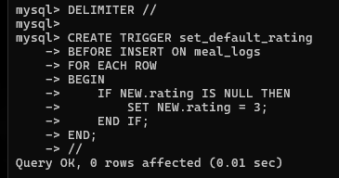

Question 2: Update ingredient quantity after meal is logged

SQL Statement:

DELIMITER //

CREATE TRIGGER reduce_ingredient_after_meal
AFTER INSERT ON meal_logs
FOR EACH ROW
BEGIN
UPDATE ingredients
SET quantity = quantity - 1
WHERE user_id = NEW.user_id;
END;
//
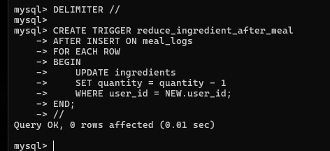

Question 3: Prevent inserting expired ingredient

SQL Statement:
DELIMITER //

CREATE TRIGGER check_expiry_date
BEFORE INSERT ON ingredients
FOR EACH ROW
BEGIN
IF NEW.expiration_date < CURDATE() THEN
SIGNAL SQLSTATE '45000'
SET MESSAGE_TEXT = 'Cannot add expired ingredient';
END IF;
END;
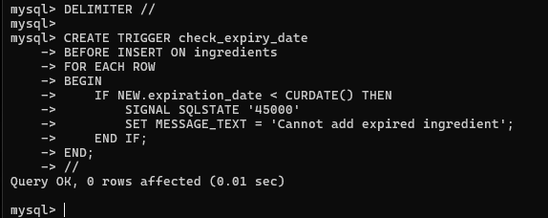

  - Complex queries based on Cursors

Question 1: Display all ingredient names using cursor

SQL Statement:
DELIMITER //

CREATE PROCEDURE get_ingredients()
BEGIN
DECLARE done INT DEFAULT 0;
DECLARE ing_name VARCHAR(100);

DECLARE cur CURSOR FOR
SELECT name FROM ingredients;

DECLARE CONTINUE HANDLER FOR NOT FOUND SET done = 1;

OPEN cur;

read_loop: LOOP
FETCH cur INTO ing_name;
IF done THEN
LEAVE read_loop;
END IF;

SELECT ing_name;
END LOOP;

CLOSE cur;
END;
//

DELIMITER ;
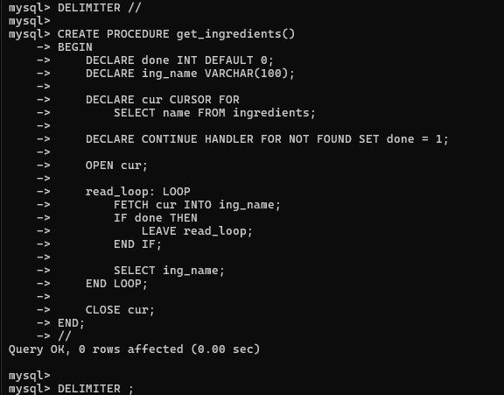

Question 2: Count total ingredients using cursor

SQL Statement:
DELIMITER //

CREATE PROCEDURE count_ingredients()
BEGIN
DECLARE done INT DEFAULT 0;
DECLARE total INT DEFAULT 0;
DECLARE ing_id INT;

DECLARE cur CURSOR FOR
SELECT ingredient_id FROM ingredients;

DECLARE CONTINUE HANDLER FOR NOT FOUND SET done = 1;

OPEN cur;

read_loop: LOOP
FETCH cur INTO ing_id;
IF done THEN
LEAVE read_loop;
END IF;

SET total = total + 1;
END LOOP;

CLOSE cur;

SELECT total AS total_ingredients;
END;
//

DELIMITER ;

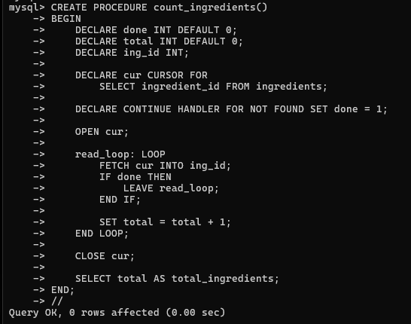

Question 3: Show ingredients with low stock (quantity < 2)

SQL Statement:
DELIMITER //

CREATE PROCEDURE low_stock()
BEGIN
DECLARE done INT DEFAULT 0;
DECLARE ing_name VARCHAR(100);
DECLARE qty DECIMAL(10,2);

DECLARE cur CURSOR FOR
SELECT name, quantity FROM ingredients;

DECLARE CONTINUE HANDLER FOR NOT FOUND SET done = 1;

OPEN cur;

read_loop: LOOP
FETCH cur INTO ing_name, qty;
IF done THEN
LEAVE read_loop;
END IF;

IF qty < 2 THEN
SELECT ing_name, qty;
END IF;
END LOOP;

CLOSE cur;
END;
//
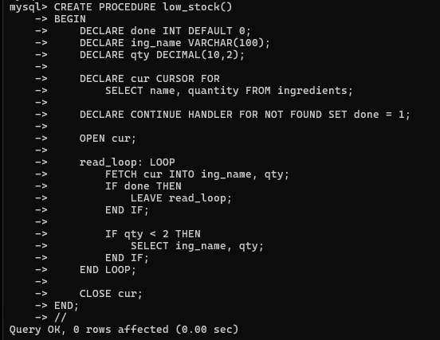

CHAPTER 4
ANALYZING THE PITFALLS, IDENTIFYING THE DEPENDENCIES, AND APPLYING NORMALIZATIONS

4.1 Analyse the Pitfalls in Relations
Before applying normalization, it is important to identify the anomalies and design flaws present in the initial unnormalized table. These pitfalls include:

Insertion Anomaly
New data cannot be inserted without providing unrelated information. For example, a new recipe cannot be added unless an ingredient is also provided.
Update Anomaly
Updating a single piece of information requires changes in multiple rows. For instance, if a user's dietary preference is stored redundantly across ingredient records, updating it in one place leaves inconsistencies elsewhere.
Deletion Anomaly
Deleting a record results in unintentional loss of other related data. For example, deleting the last meal log for a user may remove the only reference to a particular recipe.

Consider the following unnormalized flat table that represents the Weight Coach App data before normalization:

user_id | user_name | email | ingredient_name | qty | unit | expiry | recipe_name | prep_time | rating
1 | Sanchit | sanchit@gmail.com | Tomato, Onion | 2,1 | kg,kg | 2026-02-01 | Veg Salad | 10 | 5
1 | Sanchit | sanchit@gmail.com | Potato | 5 | kg | 2026-03-01 | Paratha | 20 | 4
2 | Riya | riya@gmail.com | Milk, Eggs | 1,12 | L,pcs | 2026-01-25 | Omelette | 10 | 4

The issues in this unnormalized table are: multiple values in a single cell (non-atomic), repeating user information, and transitive dependencies between non-key attributes.

4.2 First Normal Form (1NF)
4.2.1 Identify Dependency
A table is in First Normal Form (1NF) if:
- All attributes contain only atomic (indivisible) values.
- Each column contains values of a single type.
- Each row is unique (identified by a primary key).

Violation found: The unnormalized table contains multi-valued attributes such as multiple ingredient names and quantities in a single cell (e.g., 'Tomato, Onion'). This violates the atomicity rule of 1NF.
4.2.2 Apply Normalization to 1NF
To achieve 1NF, each multi-valued attribute is split into separate rows, ensuring each field holds a single atomic value:

Table Before 1NF (Unnormalized):
user_id | user_name | ingredient_name | qty | unit | recipe_name
1 | Sanchit | Tomato, Onion | 2,1 | kg,kg | Veg Salad
2 | Riya | Milk, Eggs | 1,12 | L,pcs | Omelette

Table After 1NF (All values are atomic):
user_id | user_name | ingredient_name | qty | unit | recipe_name
1 | Sanchit | Tomato | 2 | kg | Veg Salad
1 | Sanchit | Onion | 1 | kg | Veg Salad
2 | Riya | Milk | 1 | L | Omelette
2 | Riya | Eggs | 12 | pcs | Omelette

Result: The table is now in 1NF — each cell holds exactly one atomic value and there are no repeating groups.

4.3 Second Normal Form (2NF)
4.3.1 Identify Dependency
A table is in Second Normal Form (2NF) if:
- It is already in 1NF.
- All non-key attributes are fully functionally dependent on the entire primary key (no partial dependencies).

In the 1NF table, the composite primary key is (user_id, ingredient_name). Partial dependencies exist:
- user_name and email depend only on user_id — not on the full composite key.
- recipe_name and prep_time depend only on recipe_id — not on ingredient data.
These partial dependencies violate 2NF.
4.3.2 Apply Normalization to 2NF
To achieve 2NF, we decompose the table by separating partial dependencies into their own tables:

Users Table (2NF):
user_id (PK) | user_name | email | dietary_preferences
1 | Sanchit Jaiswal | sanchit@gmail.com | Vegetarian
2 | Riya Raj | riya@gmail.com | Non-Vegetarian

Ingredients Table (2NF):
ingredient_id (PK) | user_id (FK) | name | quantity | unit | expiration_date
1 | 1 | Tomato | 2 | kg | 2026-02-01
2 | 1 | Onion | 1 | kg | 2026-02-15
3 | 2 | Milk | 1 | L | 2026-01-25

Recipes Table (2NF):
recipe_id (PK) | name | instructions | prep_time | difficulty_level
1 | Veg Salad | Mix vegetables | 10 | Easy
2 | Omelette | Cook eggs | 10 | Easy
3 | Paneer Butter Masala | Cook paneer with gravy | 30 | Medium

Result: All partial dependencies are removed. Each non-key attribute is fully dependent on its respective primary key.

4.4 Third Normal Form (3NF)
4.4.1 Identify Dependency
A table is in Third Normal Form (3NF) if:
- It is already in 2NF.
- There are no transitive dependencies — i.e., non-key attributes should not depend on other non-key attributes.

After achieving 2NF, consider a scenario where the Ingredients table contains a location_type column (e.g., 'Fridge' → 'Cold Storage', 'Pantry' → 'Dry Storage'). Here: ingredient_id → location → location_type. The attribute location_type depends on location (a non-key attribute), creating a transitive dependency that violates 3NF.
4.4.2 Apply Normalization to 3NF
We extract the transitive dependency into a separate StorageLocations table:

StorageLocations Table (3NF):
location (PK) | location_type | temperature_range
Fridge | Cold Storage | 0–4°C
Freezer | Frozen Storage | -18 to -20°C
Pantry | Dry Storage | Room Temperature

Ingredients Table (3NF) — location_type removed:
ingredient_id (PK) | user_id (FK) | name | quantity | unit | expiration_date | location (FK)
1 | 1 | Tomato | 2.00 | kg | 2026-02-01 | Fridge
2 | 1 | Potato | 5.00 | kg | 2026-03-01 | Pantry
3 | 2 | Milk | 1.00 | L | 2026-01-25 | Fridge

Result: The transitive dependency is eliminated. All non-key attributes now depend solely and directly on the primary key.

4.5 Boyce-Codd Normal Form (BCNF)
4.5.1 Identify Dependency
BCNF is a stronger version of 3NF. A table is in BCNF if:
- It is in 3NF.
- For every functional dependency X → Y, X must be a superkey.

Consider the Recipe_Ingredients table with functional dependencies:
- (recipe_id, ingredient_name) → quantity, unit [composite PK determines other attributes — valid]
- ingredient_name → unit [ingredient name alone determines the standard unit]
The dependency ingredient_name → unit violates BCNF because ingredient_name is not a superkey. For example, 'Milk' always uses 'litre' regardless of the recipe.
4.5.2 Apply Normalization to BCNF
We decompose the Recipe_Ingredients table to remove the violating dependency:

Ingredient_Units Table (BCNF):
ingredient_name (PK) | standard_unit
Tomato | kg
Milk | litre
Rice | kg
Eggs | pieces

Recipe_Ingredients Table (BCNF) — unit removed:
recipe_id (FK) | ingredient_name (FK) | quantity
1 | Tomato | 0.25
1 | Onion | 0.10
2 | Eggs | 2
4 | Milk | 0.25

Result: Every determinant in each table is now a superkey. BCNF is achieved.

4.6 Fourth Normal Form (4NF)
4.6.1 Identify Dependency
A table is in Fourth Normal Form (4NF) if:
- It is in BCNF.
- It has no multi-valued dependencies (MVD) — i.e., one attribute should not independently determine multiple values of two other attributes.

Consider a hypothetical UserPreferences table storing user dietary restrictions and preferred cuisines:
user_id | dietary_restriction | preferred_cuisine
1 | Vegetarian | Indian
1 | Vegetarian | Italian
1 | Gluten-Free | Indian
1 | Gluten-Free | Italian

Here, user_id →→ dietary_restriction and user_id →→ preferred_cuisine are independent multi-valued dependencies. This causes data redundancy — every combination must be stored. This violates 4NF.
4.6.2 Apply Normalization to 4NF
Decompose into two separate tables, each capturing one multi-valued dependency:

User_Dietary_Restrictions Table (4NF):
user_id (PK) | dietary_restriction (PK)
1 | Vegetarian
1 | Gluten-Free
2 | Non-Vegetarian
3 | Vegan

User_Preferred_Cuisines Table (4NF):
user_id (PK) | preferred_cuisine (PK)
1 | Indian
1 | Italian
2 | Indian
3 | Mediterranean

Result: Multi-valued dependencies are eliminated. Each table now represents one independent fact about the entity.

4.7 Fifth Normal Form (5NF)
4.7.1 Identify Dependency
A table is in Fifth Normal Form (5NF) — also called Project-Join Normal Form (PJNF) — if:
- It is in 4NF.
- It cannot be decomposed into smaller tables without loss of information (no join dependencies that are not implied by candidate keys).

Consider a three-way relationship among users, recipes, and dietary categories:
user_id | recipe_id | dietary_category
1 | 3 | Vegetarian
1 | 5 | Vegan
2 | 2 | Non-Vegetarian
3 | 3 | Vegan
3 | 7 | Vegan

A 5NF violation would occur if every pair of these three attributes independently determines the third, forcing every combination to be stored. This leads to redundancy and makes the table non-decomposable without loss.
4.7.2 Apply Normalization to 5NF
We decompose the three-way table into three binary join tables, each capturing a pair-wise relationship:

User_Recipe Table (5NF):
user_id (PK) | recipe_id (PK)
1 | 3
1 | 5
2 | 2
3 | 3
3 | 7

Recipe_Category Table (5NF):
recipe_id (PK) | dietary_category (PK)
2 | Non-Vegetarian
3 | Vegetarian
5 | Vegan
7 | Vegan

User_Category Table (5NF):
user_id (PK) | dietary_category (PK)
1 | Vegetarian
1 | Vegan
2 | Non-Vegetarian
3 | Vegan

Result: The three-way relationship is losslessly decomposed. Joining the three tables reconstructs the original information without any spurious tuples. The schema is now in 5NF.

Summary of Normalization Applied to Weight Coach App:
Normal Form | Key Requirement | Violation Found | Action Taken
1NF | Atomic values, no repeating groups | Multi-valued ingredient fields | Split into separate rows
2NF | No partial dependencies | user_name, recipe_name partially dependent | Decomposed into Users, Recipes tables
3NF | No transitive dependencies | location → location_type transitivity | Created StorageLocations table
BCNF | Every determinant is a superkey | ingredient_name → unit violation | Created Ingredient_Units table
4NF | No multi-valued dependencies | User preferences dual MVD | Split into two preference tables
5NF | No join dependencies | Three-way user-recipe-category relation | Decomposed into three binary tables

CHAPTER 5
IMPLEMENTATION OF CONCURRENCY CONTROL AND RECOVERY MECHANISMS

5.1 Introduction to Transactions
A transaction in a database system is a logical unit of work that consists of one or more SQL operations. It is executed as a single, indivisible unit — either all operations complete successfully or none of them take effect. Transactions are fundamental to ensuring data consistency and reliability in the Weight Coach App, especially when multiple users are simultaneously updating ingredients, logging meals, or modifying recipes.
5.1.1 Properties of Transactions (ACID)
Transactions in the Weight Coach App follow the ACID properties:

Property | Description | Example in Weight Coach App
Atomicity | All operations in a transaction succeed or all are rolled back. | When logging a meal, both the meal_logs INSERT and ingredients quantity UPDATE must both succeed or both fail.
Consistency | A transaction brings the database from one valid state to another. | Inserting an ingredient must not violate the foreign key constraint on user_id.
Isolation | Concurrent transactions do not interfere with each other. | Two users updating inventory simultaneously see a consistent state due to locking.
Durability | Once committed, changes persist even after system failure. | A committed meal log remains recorded even after a server crash.
5.1.2 Transaction States
A transaction progresses through the following states during its lifecycle:

State | Description
Active | The transaction is currently executing its operations.
Partially Committed | The final operation has been executed but changes are not yet written to disk.
Committed | All changes have been permanently saved to the database.
Failed | An error occurred and the transaction cannot proceed.
Aborted / Rolled Back | The transaction has been rolled back and the database is restored to its previous state.

5.2 Transaction Control Language (TCL)
Transaction Control Language (TCL) commands are used to manage transactions in SQL. The key TCL commands used in the Weight Coach App are:
5.2.1 SAVEPOINT
A SAVEPOINT creates an intermediate checkpoint within a transaction. If an error occurs after a savepoint, the transaction can be rolled back to that specific point without undoing all prior changes.

Syntax:
SAVEPOINT savepoint_name;

Example — Creating a savepoint after adding an ingredient:
START TRANSACTION;
INSERT INTO ingredients (user_id, name, quantity, unit, expiration_date, location) VALUES (1, 'Tomato', 2.00, 'kg', '2026-02-01', 'Fridge');
SAVEPOINT after_ingredient_insert;
5.2.2 COMMIT
The COMMIT command permanently saves all changes made during the current transaction to the database. Once committed, changes cannot be undone with ROLLBACK.

Syntax:
COMMIT;

Example — Committing a meal log entry:
START TRANSACTION;
INSERT INTO meal_logs (user_id, recipe_id, consumed_date, rating) VALUES (1, 3, CURDATE(), 5);
UPDATE ingredients SET quantity = quantity - 0.25 WHERE user_id = 1 AND name = 'Tomato'; COMMIT;
5.2.3 ROLLBACK
The ROLLBACK command undoes all changes made since the last COMMIT or to a specific SAVEPOINT. It is used when an error is detected and the transaction must be reversed.

Syntax:
ROLLBACK; -- Or rollback to a savepoint:
ROLLBACK TO savepoint_name;

Example — Rolling back after detecting invalid data:
START TRANSACTION;
INSERT INTO meal_logs (user_id, recipe_id, consumed_date, rating) VALUES (1, 999, CURDATE(), 3);
-- recipe_id 999 does not exist
-- Foreign key constraint will fail, so we rollback: ROLLBACK;

5.3 Transactions for the Weight Coach App
The following five transactions demonstrate realistic database operations in the Weight Coach App, incorporating SAVEPOINT, COMMIT, and ROLLBACK mechanisms.
5.3.1 Transaction 1 — Log a Meal and Update Inventory
This transaction records a meal consumption and simultaneously reduces the corresponding ingredient quantities. A savepoint is used to allow partial rollback if the ingredient update fails.

START TRANSACTION;
-- Step 1: Log the meal
INSERT INTO meal_logs (user_id, recipe_id, consumed_date, rating) VALUES (1, 1, CURDATE(), 5);
-- Step 2: Savepoint after meal log
SAVEPOINT after_meal_log;
-- Step 3: Deduct ingredients used in Paneer Butter Masala
UPDATE ingredients SET quantity = quantity - 0.25 WHERE user_id = 1 AND name = 'Tomato'; UPDATE ingredients SET quantity = quantity - 0.10 WHERE user_id = 1 AND name = 'Onion';
-- Step 4: If ingredient update fails, rollback to savepoint only -- ROLLBACK TO after_meal_log; -- Step 5: All operations successful - commit COMMIT;

Expected Output: A new row in meal_logs is inserted and ingredient quantities for user 1 are reduced accordingly. The meal log is preserved even if rollback to savepoint is triggered.
5.3.2 Transaction 2 — Add New Ingredient with Expiry Validation
This transaction adds a new ingredient to the user's inventory. If the ingredient is already expired at the time of insertion, the transaction is rolled back.

START TRANSACTION;
-- Step 1: Attempt to add a new ingredient INSERT INTO ingredients (user_id, name, quantity, unit, expiration_date, location, calories_per_unit) VALUES (2, 'Spinach', 0.50, 'kg', '2026-01-15', 'Fridge', 23);
SAVEPOINT after_spinach_insert;
-- Step 2: Validate expiry (simulate check) -- If expiration_date < CURDATE(), rollback -- Assuming this check detects expiry:
ROLLBACK TO after_spinach_insert;
-- Step 3: Try adding a fresh alternative
INSERT INTO ingredients (user_id, name, quantity, unit, expiration_date, location, calories_per_unit) VALUES (2, 'Kale', 0.30, 'kg', '2026-03-01', 'Fridge', 35); COMMIT;

Expected Output: The expired spinach entry is rolled back to the savepoint. The fresh kale entry is committed successfully. The trigger check_expiry_date (defined in Chapter 3) would also raise an error for expired inserts automatically.
5.3.3 Transaction 3 — Register New User and Set Initial Preferences
This transaction creates a new user profile and immediately sets their dietary preferences. If any step fails, the entire registration is rolled back to maintain data integrity.

START TRANSACTION;
-- Step 1: Insert new user
INSERT INTO users (name, email, password, dietary_preferences, created_at) VALUES ('Kavya Bhat', 'kavya@gmail.com', 'securepass123', 'Vegetarian', NOW()); SAVEPOINT after_user_insert;
-- Step 2: Add initial ingredients to their inventory
INSERT INTO ingredients (user_id, name, quantity, unit, expiration_date, location) VALUES (LAST_INSERT_ID(), 'Rice', 5.00, 'kg', '2026-06-01', 'Pantry');
INSERT INTO ingredients (user_id, name, quantity, unit, expiration_date, location) VALUES (LAST_INSERT_ID(), 'Dal', 2.00, 'kg', '2026-05-01', 'Pantry');
-- Step 3: Commit if all steps succeed
COMMIT;

Expected Output: A new user record is created. Two starter ingredients are added to their pantry. If the ingredient INSERT fails (e.g., invalid user_id), the system rolls back to after_user_insert, preserving the user record while discarding failed ingredient entries.
5.3.4 Transaction 4 — Generate Smart Shopping List
This transaction calculates missing ingredients for a planned recipe and inserts them into a shopping_list table. A savepoint allows recovery if duplicate entries are detected.

START TRANSACTION;
-- Step 1: Identify recipe ingredients not in user inventory
-- (Simplified: manually listing missing items for recipe_id = 2 - Chicken Curry)
SAVEPOINT before_shopping_insert;
INSERT INTO shopping_list (user_id, ingredient_name, quantity_needed, unit) VALUES (5, 'Chicken', 1.00, 'kg');
INSERT INTO shopping_list (user_id, ingredient_name, quantity_needed, unit) VALUES (5, 'Garam Masala', 0.05, 'kg');
SAVEPOINT after_shopping_insert;
-- Step 2: If user already has an item, rollback last insert only -- ROLLBACK TO before_shopping_insert;
-- Step 3: Commit the finalized shopping list COMMIT;

Expected Output: Missing ingredients for Chicken Curry are added to the user's shopping list. The use of SAVEPOINT allows granular rollback of individual items without discarding the entire list.
5.3.5 Transaction 5 — Delete Expired Ingredients with Recovery
This transaction removes all expired ingredients from the inventory. A savepoint before deletion allows recovery if an important ingredient is accidentally removed.

START TRANSACTION;
-- Step 1: Create savepoint before deletion
SAVEPOINT before_cleanup;
-- Step 2: Delete all ingredients past their expiration date
DELETE FROM ingredients WHERE expiration_date < CURDATE();
SAVEPOINT after_cleanup;
-- Step 3: Verify deletion count (simulated validation)
-- If too many items deleted (possible error), rollback to savepoint
-- SELECT ROW_COUNT() → if > expected threshold, rollback
-- Assuming cleanup is valid:
COMMIT;
-- If something went wrong:
-- ROLLBACK TO before_cleanup;

Expected Output: All expired ingredient records are permanently removed. The savepoint before_cleanup allows the DBA or application logic to inspect the deletion count and rollback if an unexpectedly large number of rows were affected.

5.4 Concurrency Control
Concurrency control ensures that multiple users can access and modify the database simultaneously without compromising data consistency. In the Weight Coach App, multiple users may concurrently update ingredient quantities, log meals, or modify recipes.
5.4.1 Concurrency Control Algorithms
The Weight Coach App uses locking-based concurrency control mechanisms supported by MySQL/PostgreSQL. The key approaches are:

Algorithm | Description | Use Case in Weight Coach App
Two-Phase Locking (2PL) | Transactions acquire all locks before releasing any. Ensures serializability. | Prevents two users from simultaneously reducing the same ingredient quantity below zero.
Optimistic Concurrency Control | Validates data at commit time; rolls back if conflict detected. | Used for reading recipe suggestions — checks if ingredients changed during recommendation.
Timestamp Ordering | Transactions ordered by timestamp; older transactions have priority. | Ensures first-come-first-served access when multiple users add the same ingredient.
5.4.2 Locking Commands
MySQL supports both row-level and table-level locking for concurrency control:

a. Row-Level Locking — SELECT ... FOR UPDATE
Locks specific rows to prevent other transactions from modifying them until the current transaction commits or rolls back.
-- Lock the ingredient row for user 1's Tomato before updating
START TRANSACTION;
SELECT * FROM ingredients WHERE user_id = 1 AND name = 'Tomato' FOR UPDATE;
-- Safely update without conflict
UPDATE ingredients SET quantity = quantity - 0.25 WHERE user_id = 1 AND name = 'Tomato'; COMMIT;

b. Table-Level Locking — LOCK TABLES
Locks an entire table for exclusive access. Used during bulk operations such as cleanup of expired ingredients.
-- Lock the ingredients table for exclusive write access
LOCK TABLES ingredients WRITE;
-- Bulk delete expired items
DELETE FROM ingredients WHERE expiration_date < CURDATE();
-- Release the lock UNLOCK TABLES;

c. Lock Mode Summary:
Lock Mode | Description
ROW SHARE | Allows concurrent access; prevents exclusive table locks by other sessions.
ROW EXCLUSIVE | Prevents share-mode locks. Used by default for DML (INSERT, UPDATE, DELETE).
SHARE | Allows queries but blocks updates and deletes from other sessions.
SHARE ROW EXCLUSIVE | More restrictive than SHARE; blocks all write operations.
EXCLUSIVE | Prevents all other access — full table lock for critical operations.

d. COMMIT — Release All Locks
COMMIT;
-- Saves all changes and releases all row/table locks acquired in the transaction

e. ROLLBACK — Undo Changes & Release Locks
ROLLBACK;
-- Undoes all uncommitted changes and releases all held locks
5.4.3 Concurrency Control Example for Weight Coach App
The following example demonstrates concurrency control when two users (User 1 and User 3) simultaneously attempt to use the last available portion of Rice from a shared household inventory:

-- Session A: User 1 wants to cook Rice and Dal (recipe_id = 5)
START TRANSACTION;
SELECT quantity FROM ingredients WHERE user_id = 3 AND name = 'Rice' FOR UPDATE;
-- Acquires row lock
-- Session B: User 3 simultaneously tries to use Rice
-- START TRANSACTION;
-- SELECT * FROM ingredients WHERE name = 'Rice' FOR UPDATE;
-- ↑ This will WAIT until Session A commits or rolls back
-- Session A continues: checks if enough stock
-- Quantity = 10 kg, need 0.5 kg → sufficient
UPDATE ingredients SET quantity = quantity - 0.50 WHERE user_id = 3 AND name = 'Rice';
INSERT INTO meal_logs (user_id, recipe_id, consumed_date, rating) VALUES (1, 5, CURDATE(), 4); COMMIT;
-- Releases lock; Session B can now proceed
-- Session B resumes with updated quantity (9.5 kg remaining)

Expected Output: Session A completes first, reducing Rice quantity from 10 kg to 9.5 kg. Session B waits for the lock, then reads the updated quantity (9.5 kg) and proceeds with its own deduction. Data integrity is maintained — the inventory never shows an incorrect quantity.

5.5 Recovery Mechanisms
Recovery mechanisms ensure that the database can be restored to a consistent state after system failures, crashes, or unexpected errors. The Weight Coach App relies on the following recovery strategies:

Recovery Technique | Description | Application in Weight Coach App
Transaction Rollback | Undo uncommitted transactions using the transaction log. | If a meal log insert fails midway, the partial changes are rolled back automatically.
SAVEPOINT-based Recovery | Rollback to a specific intermediate state within a transaction. | If ingredient deduction fails after meal logging, rollback to the savepoint, preserving the meal log.
Redo Logging | Re-applies committed transactions lost due to system crash. | Ensures meal logs and ingredient updates committed before a crash are not lost.
Checkpoint Recovery | Periodic saving of database state to reduce recovery time. | Regular checkpoints ensure only transactions after the last checkpoint need to be redone after a crash.
Backup & Restore | Periodic full or incremental backups for catastrophic failure recovery. | Weekly full backups and daily incremental backups of the PostgreSQL database ensure data durability.

The combination of ACID-compliant transactions, locking-based concurrency control, and robust recovery mechanisms ensures that the Weight Coach App maintains data integrity and availability even under concurrent multi-user access and unexpected system failures.

CHAPTER 6
FRONT-END AND BACK-END CODE OF WEIGHT COACH APP
6.1 Front–End Module codes
Authorization Code
const express = require('express');
const bcrypt = require('bcrypt');
const jwt = require('jsonwebtoken');
const pool = require('../config/db');
require('dotenv').config();
const router = express.Router();
// POST /api/auth/signup
router.post('/signup', async (req, res) => {
try {
const { name, email, password } = req.body;
if (!name || !email || !password) {
return res.status(400).json({ error: 'Name, email, and password are required.' });
}
// Check if user exists
const [existing] = await pool.query('SELECT user_id FROM users WHERE email = ?', [email]);
if (existing.length > 0) {
return res.status(409).json({ error: 'Email already registered.' });
}
// Hash password
const salt = await bcrypt.genSalt(10);
const password_hash = await bcrypt.hash(password, salt);
// Insert user
const [result] = await pool.query(
'INSERT INTO users (name, email, password_hash) VALUES (?, ?, ?)',
[name, email, password_hash]
);
const token = jwt.sign(
{ userId: result.insertId, email },
process.env.JWT_SECRET,
{ expiresIn: process.env.JWT_EXPIRES_IN || '7d' }
);
res.status(201).json({
message: 'User registered successfully.',
token,
user: { id: result.insertId, name, email },
});
} catch (err) {
console.error('Signup error:', err);
res.status(500).json({ error: 'Server error during signup.' });
}
});
// POST /api/auth/login
router.post('/login', async (req, res) => {
try {
const { email, password } = req.body;
if (!email || !password) {
return res.status(400).json({ error: 'Email and password are required.' });
}
const [rows] = await pool.query('SELECT * FROM users WHERE email = ?', [email]);
if (rows.length === 0) {
return res.status(401).json({ error: 'Invalid email or password.' });
}

const user = rows[0];
const validPassword = await bcrypt.compare(password, user.password_hash);
if (!validPassword) {
return res.status(401).json({ error: 'Invalid email or password.' });
const token = jwt.sign(
{ userId: user.user_id, email: user.email },
process.env.JWT_SECRET,
{ expiresIn: process.env.JWT_EXPIRES_IN || '7d' }
);
res.json({
message: 'Login successful.',
token,
user: { id: user.user_id, name: user.name, email: user.email },
});
} catch (err) {
console.error('Login error:', err);
res.status(500).json({ error: 'Server error during login.' });
}
});
module.exports = router;

Ingredients Code
const express = require('express');
const pool = require('../config/db');
const auth = require('../middleware/auth');
const router = express.Router();
// GET /api/ingredients — all ingredients for logged-in user
router.get('/', auth, async (req, res) => {
try {
const [rows] = await pool.query(
`SELECT i.*, sl.location_type, sl.temperature_range,
DATEDIFF(i.expiration_date, CURDATE()) AS days_until_expiry
FROM ingredients i
LEFT JOIN storage_locations sl ON i.location = sl.location
WHERE i.user_id = ?
ORDER BY i.expiration_date ASC`,
[req.user.userId]
);
res.json(rows);
} catch (err) {
console.error('Get ingredients error:', err);
res.status(500).json({ error: 'Failed to fetch ingredients.' });
}
});
// GET /api/ingredients/expiring — items expiring within 3 days
router.get('/expiring', auth, async (req, res) => {
try {
const [rows] = await pool.query(
`SELECT i.*, DATEDIFF(i.expiration_date, CURDATE()) AS days_until_expiry
FROM ingredients i
WHERE i.user_id = ?
AND i.expiration_date <= DATE_ADD(CURDATE(), INTERVAL 3 DAY)
AND i.expiration_date >= CURDATE()
ORDER BY i.expiration_date ASC`,
[req.user.userId]
);
res.json(rows);
} catch (err) {
console.error('Get expiring error:', err);
res.status(500).json({ error: 'Failed to fetch expiring ingredients.' });
}
});
// POST /api/ingredients — add ingredient
router.post('/', auth, async (req, res) => {
try {
const { name, quantity, unit, expiration_date, location, calories_per_unit } = req.body;
if (!name) {
return res.status(400).json({ error: 'Ingredient name is required.' });
}
const [result] = await pool.query(
`INSERT INTO ingredients (user_id, name, quantity, unit, expiration_date, location, calories_per_unit)
VALUES (?, ?, ?, ?, ?, ?, ?)`,
[req.user.userId, name, quantity || 0, unit || 'g', expiration_date || null, location || 'pantry', calories_per_unit || 0]
);
const [newItem] = await pool.query('SELECT * FROM ingredients WHERE ingredient_id = ?', [result.insertId]);
res.status(201).json(newItem[0]);
} catch (err) {
console.error('Add ingredient error:', err);
if (err.sqlState === '45000') {
return res.status(400).json({ error: err.message });
}
res.status(500).json({ error: 'Failed to add ingredient.' });
}
});

// PUT /api/ingredients/:id — update ingredient
router.put('/:id', auth, async (req, res) => {
try {
const { name, quantity, unit, expiration_date, location, calories_per_unit } = req.body;
// Verify ownership
const [existing] = await pool.query(
'SELECT * FROM ingredients WHERE ingredient_id = ? AND user_id = ?',
[req.params.id, req.user.userId]
);
if (existing.length === 0) {
return res.status(404).json({ error: 'Ingredient not found.' });
}
await pool.query(
`UPDATE ingredients SET name = ?, quantity = ?, unit = ?, expiration_date = ?, location = ?, calories_per_unit = ?
WHERE ingredient_id = ? AND user_id = ?`,
[
name || existing[0].name,
quantity !== undefined ? quantity : existing[0].quantity,
unit || existing[0].unit,
expiration_date || existing[0].expiration_date,
location || existing[0].location,
calories_per_unit !== undefined ? calories_per_unit : existing[0].calories_per_unit,
req.params.id,
req.user.userId,
]
);
const [updated] = await pool.query('SELECT * FROM ingredients WHERE ingredient_id = ?', [req.params.id]);
res.json(updated[0]);
} catch (err) {
console.error('Update ingredient error:', err);
res.status(500).json({ error: 'Failed to update ingredient.' });
}
});
// DELETE /api/ingredients/:id — delete ingredient
router.delete('/:id', auth, async (req, res) => {
try {
const [result] = await pool.query(
'DELETE FROM ingredients WHERE ingredient_id = ? AND user_id = ?',
[req.params.id, req.user.userId]
);
if (result.affectedRows === 0) {
return res.status(404).json({ error: 'Ingredient not found.' });
}
res.json({ message: 'Ingredient deleted.' });
} catch (err) {
console.error('Delete ingredient error:', err);
res.status(500).json({ error: 'Failed to delete ingredient.' });
}
});
module.exports = router;
Meal Logs
const express = require('express');
const pool = require('../config/db');
cost auth = require('../middleware/auth');
const router = express.Router();
// GET /api/meal-logs — user's meal history
router.get('/', auth, async (req, res) => {
try {
const [rows] = await pool.query(
`SELECT ml.log_id, ml.consumed_date, ml.rating, ml.notes,
r.recipe_id, r.name AS recipe_name, r.difficulty_level, r.prep_time
FROM meal_logs ml
LEFT JOIN recipes r ON ml.recipe_id = r.recipe_id
WHERE ml.user_id = ?
ORDER BY ml.consumed_date DESC`,
[req.user.userId]
);
res.json(rows);
} catch (err) {
console.error('Get meal logs error:', err);
res.status(500).json({ error: 'Failed to fetch meal logs.' });
}
});
// POST /api/meal-logs — log a meal
router.post('/', auth, async (req, res) => {
try {
const { recipe_id, consumed_date, rating, notes } = req.body;
if (!recipe_id || !consumed_date) {
return res.status(400).json({ error: 'Recipe and date are required.' });
}
const [result] = await pool.query(
`INSERT INTO meal_logs (user_id, recipe_id, consumed_date, rating, notes)
VALUES (?, ?, ?, ?, ?)`,
[req.user.userId, recipe_id, consumed_date, rating || null, notes || null]
);

const [newLog] = await pool.query(
`SELECT ml.*, r.name AS recipe_name
FROM meal_logs ml
LEFT JOIN recipes r ON ml.recipe_id = r.recipe_id
WHERE ml.log_id = ?`,
[result.insertId]
);
res.status(201).json(newLog[0]);
} catch (err) {
console.error('Log meal error:', err);
res.status(500).json({ error: 'Failed to log meal.' });
}
});
// DELETE /api/meal-logs/:id — delete a meal log
router.delete('/:id', auth, async (req, res) => {
try {
const [result] = await pool.query(
'DELETE FROM meal_logs WHERE log_id = ? AND user_id = ?',
[req.params.id, req.user.userId]
);
if (result.affectedRows === 0) {
return res.status(404).json({ error: 'Meal log not found.' });
}
res.json({ message: 'Meal log deleted.' });
} catch (err) {
console.error('Delete meal log error:', err);
res.status(500).json({ error: 'Failed to delete meal log.' });
}
});

// GET /api/meal-logs/stats — meal statistics for dashboard
router.get('/stats', auth, async (req, res) => {
try {
const [stats] = await pool.query(
`SELECT COUNT(*) AS total_meals,
ROUND(AVG(rating), 1) AS avg_rating,
COUNT(DISTINCT recipe_id) AS unique_recipes
FROM meal_logs
WHERE user_id = ?`,
[req.user.userId]
);
const [recent] = await pool.query(
`SELECT ml.consumed_date, ml.rating, r.name AS recipe_name
FROM meal_logs ml
LEFT JOIN recipes r ON ml.recipe_id = r.recipe_id
WHERE ml.user_id = ?
ORDER BY ml.consumed_date DESC
LIMIT 5`,
[req.user.userId]
);
res.json({ ...stats[0], recent_meals: recent });
} catch (err) {
console.error('Meal stats error:', err);
res.status(500).json({ error: 'Failed to fetch meal stats.' });
}
});
module.exports = router;

Profile
const express = require('express');
const pool = require('../config/db');
const auth = require('../middleware/auth');
const router = express.Router();
// GET /api/profile — user profile with dietary preferences and categories
router.get('/', auth, async (req, res) => {
try {
const [users] = await pool.query(
'SELECT user_id, name, email, created_at FROM users WHERE user_id = ?',
[req.user.userId]
);
if (users.length === 0) {
return res.status(404).json({ error: 'User not found.' });
}
const user = users[0];
// Get dietary preferences (4NF table)
const [prefs] = await pool.query(
'SELECT dietary_preference FROM user_dietary_preferences WHERE user_id = ?',
[req.user.userId]
);
user.dietary_preferences = prefs.map(p => p.dietary_preference);
// Get category preferences (5NF table)
const [cats] = await pool.query(
'SELECT category FROM user_categories WHERE user_id = ?',
[req.user.userId]
);
user.categories = cats.map(c => c.category);

// Get stats
const [ingredientCount] = await pool.query(
'SELECT COUNT(*) AS count FROM ingredients WHERE user_id = ?',
[req.user.userId]
);
const [mealCount] = await pool.query(
'SELECT COUNT(*) AS count FROM meal_logs WHERE user_id = ?',
[req.user.userId]
);
const [expiringCount] = await pool.query(
`SELECT COUNT(*) AS count FROM ingredients
WHERE user_id = ? AND expiration_date <= DATE_ADD(CURDATE(), INTERVAL 3 DAY)
AND expiration_date >= CURDATE()`,
[req.user.userId]
);

user.stats = {
total_ingredients: ingredientCount[0].count,
total_meals: mealCount[0].count,
expiring_items: expiringCount[0].count,
};

res.json(user);
} catch (err) {
console.error('Get profile error:', err);
res.status(500).json({ error: 'Failed to fetch profile.' });
}
});

// PUT /api/profile — update user name/email
router.put('/', auth, async (req, res) => {
try {
const { name, email } = req.body;

await pool.query(
'UPDATE users SET name = COALESCE(?, name), email = COALESCE(?, email) WHERE user_id = ?',
[name, email, req.user.userId]
);

const [updated] = await pool.query(
'SELECT user_id, name, email, created_at FROM users WHERE user_id = ?',
[req.user.userId]
);
res.json(updated[0]);
} catch (err) {
console.error('Update profile error:', err);
if (err.code === 'ER_DUP_ENTRY') {
return res.status(409).json({ error: 'Email already in use.' });
}
res.status(500).json({ error: 'Failed to update profile.' });
}
});

// PUT /api/profile/preferences — update dietary preferences (4NF)
router.put('/preferences', auth, async (req, res) => {
try {
const { dietary_preferences, categories } = req.body;

// Replace dietary preferences
if (Array.isArray(dietary_preferences)) {
await pool.query('DELETE FROM user_dietary_preferences WHERE user_id = ?', [req.user.userId]);
for (const pref of dietary_preferences) {
await pool.query(
'INSERT INTO user_dietary_preferences (user_id, dietary_preference) VALUES (?, ?)',
[req.user.userId, pref]
);
}
}

// Replace category preferences (5NF)
if (Array.isArray(categories)) {
await pool.query('DELETE FROM user_categories WHERE user_id = ?', [req.user.userId]);
for (const cat of categories) {
await pool.query(
'INSERT INTO user_categories (user_id, category) VALUES (?, ?)',
[req.user.userId, cat]
);
}
}

// Return updated preferences
const [prefs] = await pool.query(
'SELECT dietary_preference FROM user_dietary_preferences WHERE user_id = ?',
[req.user.userId]
);
const [cats] = await pool.query(
'SELECT category FROM user_categories WHERE user_id = ?',
[req.user.userId]
);

res.json({
dietary_preferences: prefs.map(p => p.dietary_preference),
categories: cats.map(c => c.category),
});
} catch (err) {
console.error('Update preferences error:', err);
res.status(500).json({ error: 'Failed to update preferences.' });
}
});

// GET /api/profile/dashboard — dashboard summary stats
router.get('/dashboard', auth, async (req, res) => {
try {
const userId = req.user.userId;

const [ingredientCount] = await pool.query(
'SELECT COUNT(*) AS total FROM ingredients WHERE user_id = ?', [userId]
);
const [expiringCount] = await pool.query(
`SELECT COUNT(*) AS total FROM ingredients
WHERE user_id = ? AND expiration_date <= DATE_ADD(CURDATE(), INTERVAL 3 DAY)
AND expiration_date >= CURDATE()`, [userId]
);
const [mealCount] = await pool.query(
'SELECT COUNT(*) AS total FROM meal_logs WHERE user_id = ?', [userId]
);
const [recipeCount] = await pool.query(
'SELECT COUNT(*) AS total FROM user_recipes WHERE user_id = ?', [userId]
);
const [recentMeals] = await pool.query(
`SELECT ml.consumed_date, ml.rating, r.name AS recipe_name
FROM meal_logs ml LEFT JOIN recipes r ON ml.recipe_id = r.recipe_id
WHERE ml.user_id = ? ORDER BY ml.consumed_date DESC LIMIT 5`, [userId]
);
const [expiringItems] = await pool.query(
`SELECT name, quantity, unit, expiration_date,
DATEDIFF(expiration_date, CURDATE()) AS days_left
FROM ingredients
WHERE user_id = ? AND expiration_date <= DATE_ADD(CURDATE(), INTERVAL 7 DAY)
AND expiration_date >= CURDATE()
ORDER BY expiration_date ASC`, [userId]
);

res.json({
total_ingredients: ingredientCount[0].total,
expiring_items: expiringCount[0].total,
meals_tracked: mealCount[0].total,
bookmarked_recipes: recipeCount[0].total,
recent_meals: recentMeals,
expiring_soon: expiringItems,
});
} catch (err) {
console.error('Dashboard error:', err);
res.status(500).json({ error: 'Failed to fetch dashboard data.' });
}
});

module.exports = router;

Recipes
const express = require('express');
const pool = require('../config/db');
const auth = require('../middleware/auth');

const router = express.Router();

// GET /api/recipes — all recipes with ingredients
router.get('/', async (req, res) => {
try {
const [recipes] = await pool.query(
`SELECT r.*, GROUP_CONCAT(DISTINCT rc.category) AS categories
FROM recipes r
LEFT JOIN recipe_categories rc ON r.recipe_id = rc.recipe_id
GROUP BY r.recipe_id
ORDER BY r.name`
);

// Fetch ingredients for each recipe
for (let recipe of recipes) {
const [ingredients] = await pool.query(
'SELECT ingredient_name, quantity, unit FROM recipe_ingredients WHERE recipe_id = ?',
[recipe.recipe_id]
);
recipe.ingredients = ingredients;
recipe.categories = recipe.categories ? recipe.categories.split(',') : [];
}

res.json(recipes);
} catch (err) {
console.error('Get recipes error:', err);
res.status(500).json({ error: 'Failed to fetch recipes.' });
}
});

// GET /api/recipes/suggestions — ranked by ingredient match for user
router.get('/suggestions', auth, async (req, res) => {
try {
const userId = req.user.userId;

const [recipes] = await pool.query(
`SELECT r.recipe_id, r.name, r.instructions, r.prep_time, r.difficulty_level, r.image_url,
COUNT(DISTINCT ri.ingredient_name) AS total_ingredients,
COUNT(DISTINCT CASE WHEN i.name IS NOT NULL THEN ri.ingredient_name END) AS matched_ingredients,
ROUND(
COUNT(DISTINCT CASE WHEN i.name IS NOT NULL THEN ri.ingredient_name END) * 100.0
/ COUNT(DISTINCT ri.ingredient_name), 0
) AS match_percentage
FROM recipes r
JOIN recipe_ingredients ri ON r.recipe_id = ri.recipe_id
LEFT JOIN ingredients i
ON LOWER(i.name) = LOWER(ri.ingredient_name)
AND i.user_id = ?
AND i.quantity > 0
GROUP BY r.recipe_id
HAVING matched_ingredients >= 1
ORDER BY match_percentage DESC, r.prep_time ASC`,
[userId]
);

// Attach ingredient details
for (let recipe of recipes) {
const [ingredients] = await pool.query(
`SELECT ri.ingredient_name, ri.quantity, ri.unit,
CASE WHEN i.name IS NOT NULL THEN 1 ELSE 0 END AS available
FROM recipe_ingredients ri
LEFT JOIN ingredients i
ON LOWER(i.name) = LOWER(ri.ingredient_name)
AND i.user_id = ?
WHERE ri.recipe_id = ?`,
[userId, recipe.recipe_id]
);
recipe.ingredients = ingredients;

const [categories] = await pool.query(
'SELECT category FROM recipe_categories WHERE recipe_id = ?',
[recipe.recipe_id]
);
recipe.categories = categories.map(c => c.category);
}

res.json(recipes);
} catch (err) {
console.error('Suggestions error:', err);
res.status(500).json({ error: 'Failed to get suggestions.' });
}
});

// GET /api/recipes/:id — single recipe detail
router.get('/:id', async (req, res) => {
try {
const [recipes] = await pool.query('SELECT * FROM recipes WHERE recipe_id = ?', [req.params.id]);
if (recipes.length === 0) {
return res.status(404).json({ error: 'Recipe not found.' });
}

const recipe = recipes[0];

const [ingredients] = await pool.query(
'SELECT ingredient_name, quantity, unit FROM recipe_ingredients WHERE recipe_id = ?',
[recipe.recipe_id]
);
recipe.ingredients = ingredients;

const [categories] = await pool.query(
'SELECT category FROM recipe_categories WHERE recipe_id = ?',
[recipe.recipe_id]
);
recipe.categories = categories.map(c => c.category);

res.json(recipe);
} catch (err) {
console.error('Get recipe error:', err);
res.status(500).json({ error: 'Failed to fetch recipe.' });
}
});

// POST /api/recipes/:id/bookmark — bookmark a recipe
router.post('/:id/bookmark', auth, async (req, res) => {
try {
await pool.query(
'INSERT IGNORE INTO user_recipes (user_id, recipe_id) VALUES (?, ?)',
[req.user.userId, req.params.id]
);
res.json({ message: 'Recipe bookmarked.' });
} catch (err) {
console.error('Bookmark error:', err);
res.status(500).json({ error: 'Failed to bookmark recipe.' });
}
});

// DELETE /api/recipes/:id/bookmark — remove bookmark
router.delete('/:id/bookmark', auth, async (req, res) => {
try {
await pool.query(
'DELETE FROM user_recipes WHERE user_id = ? AND recipe_id = ?',
[req.user.userId, req.params.id]
);
res.json({ message: 'Bookmark removed.' });
} catch (err) {
console.error('Remove bookmark error:', err);
res.status(500).json({ error: 'Failed to remove bookmark.' });
}
});

// GET /api/recipes/bookmarked/list — get user's bookmarked recipes
router.get('/bookmarked/list', auth, async (req, res) => {
try {
const [recipes] = await pool.query(
`SELECT r.*
FROM recipes r
JOIN user_recipes ur ON r.recipe_id = ur.recipe_id
WHERE ur.user_id = ?
ORDER BY r.name`,
[req.user.userId]
);

for (let recipe of recipes) {
const [ingredients] = await pool.query(
'SELECT ingredient_name, quantity, unit FROM recipe_ingredients WHERE recipe_id = ?',
[recipe.recipe_id]
);
recipe.ingredients = ingredients;
}

res.json(recipes);
} catch (err) {
console.error('Get bookmarks error:', err);
res.status(500).json({ error: 'Failed to fetch bookmarked recipes.' });
}
});

module.exports = router;

6.2 Database connectivity
-- ============================================================
-- WEIGHT COACH APP — Fully Normalized Schema (1NF → 5NF)
-- Database: MySQL 8.0
-- ============================================================

DROP DATABASE IF EXISTS weight_coach_db;
CREATE DATABASE weight_coach_db
CHARACTER SET utf8mb4
COLLATE utf8mb4_unicode_ci;

USE weight_coach_db;

SET FOREIGN_KEY_CHECKS = 0;

-- ============================================================
-- TABLE: users (1NF — atomic values only)
-- ============================================================
CREATE TABLE users (
user_id INT AUTO_INCREMENT PRIMARY KEY,
name VARCHAR(100) NOT NULL,
email VARCHAR(255) UNIQUE NOT NULL,
password_hash VARCHAR(255) NOT NULL,
created_at TIMESTAMP DEFAULT CURRENT_TIMESTAMP
);
-- ============================================================
-- TABLE: user_dietary_preferences (4NF — removes multi-valued dependency)
-- ============================================================
CREATE TABLE user_dietary_preferences (
user_id INT NOT NULL,
dietary_preference VARCHAR(50) NOT NULL,
PRIMARY KEY (user_id, dietary_preference),
FOREIGN KEY (user_id) REFERENCES users(user_id) ON DELETE CASCADE
);
-- ============================================================
-- TABLE: storage_locations (3NF — removes transitive dependency)
-- ============================================================
CREATE TABLE storage_locations (
location VARCHAR(50) PRIMARY KEY,
location_type VARCHAR(50) NOT NULL,
temperature_range VARCHAR(30)
);

-- ============================================================
-- TABLE: ingredient_units (BCNF — every determinant is a super key)
-- ============================================================
CREATE TABLE ingredient_units (
ingredient_name VARCHAR(100) PRIMARY KEY,
standard_unit VARCHAR(20) NOT NULL
);
-- ============================================================
-- TABLE: ingredients (2NF — no partial dependency)
-- ============================================================
CREATE TABLE ingredients (
ingredient_id INT AUTO_INCREMENT PRIMARY KEY,
user_id INT NOT NULL,
name VARCHAR(100) NOT NULL,
quantity DECIMAL(10,2) DEFAULT 0,
unit VARCHAR(20),
expiration_date DATE,
location VARCHAR(50),
calories_per_unit INT DEFAULT 0,
added_date TIMESTAMP DEFAULT CURRENT_TIMESTAMP,
FOREIGN KEY (user_id) REFERENCES users(user_id) ON DELETE CASCADE,
FOREIGN KEY (location) REFERENCES storage_locations(location) ON UPDATE CASCADE
);
-- ============================================================
-- TABLE: recipes (1NF)
-- ============================================================
CREATE TABLE recipes (
recipe_id INT AUTO_INCREMENT PRIMARY KEY,
name VARCHAR(200) NOT NULL,
instructions TEXT,
prep_time INT,
difficulty_level VARCHAR(20),
image_url VARCHAR(500)
);
-- ============================================================
-- TABLE: recipe_ingredients (BCNF — composite PK, determinant is super key)
-- ============================================================
CREATE TABLE recipe_ingredients (
recipe_id INT NOT NULL,
ingredient_name VARCHAR(100) NOT NULL,
quantity DECIMAL(10,2),
unit VARCHAR(20),
PRIMARY KEY (recipe_id, ingredient_name),
FOREIGN KEY (recipe_id) REFERENCES recipes(recipe_id) ON DELETE CASCADE
);
-- ============================================================
-- TABLE: meal_logs (2NF)
-- ============================================================
CREATE TABLE meal_logs (
log_id INT AUTO_INCREMENT PRIMARY KEY,
user_id INT NOT NULL,
recipe_id INT,
consumed_date DATE NOT NULL,
rating INT CHECK (rating BETWEEN 1 AND 5),
notes TEXT,
FOREIGN KEY (user_id) REFERENCES users(user_id) ON DELETE CASCADE,
FOREIGN KEY (recipe_id) REFERENCES recipes(recipe_id) ON DELETE SET NULL
);
-- ============================================================
-- TABLE: user_recipes (5NF — decomposes join dependency)
-- ============================================================
CREATE TABLE user_recipes (
user_id INT NOT NULL,
recipe_id INT NOT NULL,
PRIMARY KEY (user_id, recipe_id),
FOREIGN KEY (user_id) REFERENCES users(user_id) ON DELETE CASCADE,
FOREIGN KEY (recipe_id) REFERENCES recipes(recipe_id) ON DELETE CASCADE
);
-- ============================================================
-- TABLE: recipe_categories (5NF)
-- ============================================================
CREATE TABLE recipe_categories (
recipe_id INT NOT NULL,
category VARCHAR(50) NOT NULL,
PRIMARY KEY (recipe_id, category),
FOREIGN KEY (recipe_id) REFERENCES recipes(recipe_id) ON DELETE CASCADE
);
-- ============================================================
-- TABLE: user_categories (5NF)
-- ============================================================
CREATE TABLE user_categories (
user_id INT NOT NULL,
category VARCHAR(50) NOT NULL,
PRIMARY KEY (user_id, category),
FOREIGN KEY (user_id) REFERENCES users(user_id) ON DELETE CASCADE
);

SET FOREIGN_KEY_CHECKS = 1;
-- ============================================================
-- SEED DATA
-- ===========================================================
-- Users (password is 'password123' hashed with bcrypt)
INSERT INTO users (name, email, password_hash) VALUES
('Alice Johnson', 'alice@example.com', '$2b$10$xJ8Kq2M5Q7mZ3vR9wL4nOeYp1sT6uA0dF3gH5jK7lM9nP2qR4sT6'),
('Bob Smith', 'bob@example.com', '$2b$10$xJ8Kq2M5Q7mZ3vR9wL4nOeYp1sT6uA0dF3gH5jK7lM9nP2qR4sT6'),
('Carol White', 'carol@example.com', '$2b$10$xJ8Kq2M5Q7mZ3vR9wL4nOeYp1sT6uA0dF3gH5jK7lM9nP2qR4sT6'),
('David Lee', 'david@example.com', '$2b$10$xJ8Kq2M5Q7mZ3vR9wL4nOeYp1sT6uA0dF3gH5jK7lM9nP2qR4sT6'),
('Eva Martinez', 'eva@example.com', '$2b$10$xJ8Kq2M5Q7mZ3vR9wL4nOeYp1sT6uA0dF3gH5jK7lM9nP2qR4sT6'),
('Frank Brown', 'frank@example.com', '$2b$10$xJ8Kq2M5Q7mZ3vR9wL4nOeYp1sT6uA0dF3gH5jK7lM9nP2qR4sT6'),
('Grace Wilson', 'grace@example.com', '$2b$10$xJ8Kq2M5Q7mZ3vR9wL4nOeYp1sT6uA0dF3gH5jK7lM9nP2qR4sT6'),
('Henry Taylor', 'henry@example.com', '$2b$10$xJ8Kq2M5Q7mZ3vR9wL4nOeYp1sT6uA0dF3gH5jK7lM9nP2qR4sT6'),
('Isabella Davis', 'isabella@example.com','$2b$10$xJ8Kq2M5Q7mZ3vR9wL4nOeYp1sT6uA0dF3gH5jK7lM9nP2qR4sT6'),
('Jack Miller', 'jack@example.com', '$2b$10$xJ8Kq2M5Q7mZ3vR9wL4nOeYp1sT6uA0dF3gH5jK7lM9nP2qR4sT6');
-- Dietary preferences (4NF)
INSERT INTO user_dietary_preferences (user_id, dietary_preference) VALUES
(1, 'vegan'), (1, 'gluten_free'),
(2, 'keto'),
(3, 'vegetarian'),
(4, 'vegan'), (4, 'gluten_free'),
(5, 'pescatarian'),
(6, 'high_protein'),
(7, 'vegetarian'), (7, 'dairy_free'),
(8, 'low_carb'),
(9, 'vegan'),
(10, 'paleo');
-- Storage locations (3NF)
INSERT INTO storage_locations (location, location_type, temperature_range) VALUES
('refrigerator', 'cold_storage', '1°C – 4°C'),
('freezer', 'frozen_storage', '-18°C – 0°C'),
('pantry', 'dry_storage', '10°C – 21°C'),
('countertop', 'room_temp', '18°C – 25°C'),
('spice_rack', 'dry_storage', '18°C – 25°C');
-- Ingredient units (BCNF)
INSERT INTO ingredient_units (ingredient_name, standard_unit) VALUES
('Spinach', 'g'), ('Almond Milk', 'ml'), ('Chickpeas', 'g'),
('Chicken Breast', 'g'), ('Rice', 'g'), ('Broccoli', 'g'),
('Eggs', 'pcs'), ('Cheddar Cheese', 'g'), ('Tomatoes', 'g'),
('Lentils', 'g'), ('Coconut Oil', 'ml'), ('Kale', 'g'),
('Salmon Fillet', 'g'), ('Asparagus', 'g'), ('Olive Oil', 'ml'),
('Ground Beef', 'g'), ('Onions', 'g'), ('Garlic', 'g'),
('Greek Yogurt', 'g'), ('Honey', 'ml'), ('Blueberries', 'g'),
('Oats', 'g'), ('Banana', 'pcs'), ('Tofu', 'g'),
('Soy Sauce', 'ml'), ('Pasta', 'g'), ('Marinara Sauce', 'ml'),
('Sweet Potato', 'g'), ('Black Beans', 'g'), ('Quinoa', 'g');
-- Ingredients
INSERT INTO ingredients (user_id, name, quantity, unit, expiration_date, location, calories_per_unit) VALUES
(1, 'Spinach', 300.00, 'g', DATE_ADD(CURDATE(), INTERVAL 2 DAY), 'refrigerator', 23),
(1, 'Almond Milk', 1.00, 'l', DATE_ADD(CURDATE(), INTERVAL 10 DAY), 'refrigerator', 17),
(1, 'Chickpeas', 500.00, 'g', DATE_ADD(CURDATE(), INTERVAL 90 DAY), 'pantry', 164),
(2, 'Chicken Breast', 600.00, 'g', DATE_ADD(CURDATE(), INTERVAL 1 DAY), 'refrigerator', 165),
(2, 'Rice', 2000.00, 'g', DATE_ADD(CURDATE(), INTERVAL 180 DAY),'pantry', 130),
(2, 'Broccoli', 400.00, 'g', DATE_ADD(CURDATE(), INTERVAL 3 DAY), 'refrigerator', 55),
(3, 'Eggs', 12.00, 'pcs', DATE_ADD(CURDATE(), INTERVAL 14 DAY), 'refrigerator', 78),
(3, 'Cheddar Cheese', 250.00, 'g', DATE_ADD(CURDATE(), INTERVAL 20 DAY), 'refrigerator', 402),
(3, 'Tomatoes', 500.00, 'g', DATE_ADD(CURDATE(), INTERVAL 5 DAY), 'refrigerator', 18),
(4, 'Lentils', 800.00, 'g', DATE_ADD(CURDATE(), INTERVAL 120 DAY),'pantry', 116),
(4, 'Coconut Oil', 500.00, 'ml', DATE_ADD(CURDATE(), INTERVAL 365 DAY),'pantry', 862),
(4, 'Kale', 250.00, 'g', DATE_ADD(CURDATE(), INTERVAL 2 DAY), 'refrigerator', 49),
(5, 'Salmon Fillet', 400.00, 'g', DATE_ADD(CURDATE(), INTERVAL 3 DAY), 'freezer', 208),
(5, 'Asparagus', 300.00, 'g', DATE_ADD(CURDATE(), INTERVAL 4 DAY), 'refrigerator', 20),
(5, 'Olive Oil', 750.00, 'ml', DATE_ADD(CURDATE(), INTERVAL 200 DAY),'pantry', 884),
(6, 'Ground Beef', 500.00, 'g', DATE_ADD(CURDATE(), INTERVAL 5 DAY), 'freezer', 250),
(6, 'Onions', 1000.00, 'g', DATE_ADD(CURDATE(), INTERVAL 30 DAY), 'pantry', 40),
(6, 'Garlic', 200.00, 'g', DATE_ADD(CURDATE(), INTERVAL 60 DAY), 'pantry', 149),
(7, 'Greek Yogurt', 500.00, 'g', DATE_ADD(CURDATE(), INTERVAL 7 DAY), 'refrigerator', 59),
(7, 'Honey', 300.00, 'ml', DATE_ADD(CURDATE(), INTERVAL 400 DAY),'pantry', 304),
(7, 'Blueberries', 250.00, 'g', DATE_ADD(CURDATE(), INTERVAL 3 DAY), 'refrigerator', 57),
(8, 'Oats', 1000.00, 'g', DATE_ADD(CURDATE(), INTERVAL 150 DAY),'pantry', 389),
(8, 'Banana', 6.00, 'pcs', DATE_ADD(CURDATE(), INTERVAL 2 DAY), 'countertop', 89),
(9, 'Tofu', 400.00, 'g', DATE_ADD(CURDATE(), INTERVAL 6 DAY), 'refrigerator', 76),
(9, 'Soy Sauce', 500.00, 'ml', DATE_ADD(CURDATE(), INTERVAL 250 DAY),'pantry', 60),
(10,'Pasta', 500.00,'g', DATE_ADD(CURDATE(), INTERVAL 200 DAY),'pantry', 158),
(10,'Marinara Sauce', 400.00,'ml', DATE_ADD(CURDATE(), INTERVAL 90 DAY), 'pantry', 45),
(1, 'Sweet Potato', 800.00, 'g', DATE_ADD(CURDATE(), INTERVAL 15 DAY), 'pantry', 86),
(2, 'Black Beans', 600.00, 'g', DATE_ADD(CURDATE(), INTERVAL 120 DAY),'pantry', 132),
(3, 'Quinoa', 500.00, 'g', DATE_ADD(CURDATE(), INTERVAL 180 DAY),'pantry', 120);

-- Recipes
INSERT INTO recipes (name, instructions, prep_time, difficulty_level) VALUES
('Vegan Chickpea Curry',
'1. Heat oil. 2. Saute onion and garlic 3 min. 3. Add spices. 4. Add chickpeas and tomatoes. 5. Simmer 20 min. 6. Serve with rice.',
30, 'Easy'),
('Grilled Chicken Broccoli Bowl',
'1. Marinate chicken. 2. Grill 6-7 min per side. 3. Steam broccoli. 4. Cook rice. 5. Assemble bowl.',
35, 'Easy'),
('Spinach and Egg Frittata',
'1. Preheat oven 375F. 2. Saute spinach and onion. 3. Beat eggs with cheese. 4. Bake 15 min.',
25, 'Medium'),
('Lentil Soup',
'1. Saute onion, garlic, carrots. 2. Add lentils and broth. 3. Simmer 25 min. 4. Season and serve.',
40, 'Easy'),
('Roasted Salmon with Asparagus',
'1. Preheat oven 400F. 2. Season salmon. 3. Toss asparagus in oil. 4. Roast 15-18 min.',
25, 'Easy'),
('Beef Stir-Fry',
'1. Slice beef. 2. Stir-fry 3 min. 3. Add vegetables. 4. Add sauces. 5. Serve over rice.',
20, 'Medium'),
('Blueberry Greek Yogurt Parfait',
'1. Layer yogurt. 2. Add blueberries. 3. Drizzle honey. 4. Top with granola.',
10, 'Easy'),
('Banana Overnight Oats',
'1. Combine oats, milk, chia seeds. 2. Add honey. 3. Refrigerate overnight. 4. Top with banana.',
5, 'Easy'),
('Tofu Teriyaki Bowl',
'1. Press and cube tofu. 2. Pan-fry until golden. 3. Make teriyaki sauce. 4. Serve over rice.',
30, 'Medium'),
('Pasta Marinara',
'1. Boil pasta. 2. Saute garlic. 3. Add marinara, simmer 10 min. 4. Toss with pasta.',
20, 'Easy'),
('Sweet Potato Black Bean Tacos',
'1. Roast sweet potato. 2. Season beans. 3. Warm tortillas. 4. Assemble.',
35, 'Easy'),
('Quinoa Power Bowl',
'1. Cook quinoa. 2. Roast vegetables. 3. Prepare dressing. 4. Assemble bowl.',
40, 'Medium'),
('Kale Caesar Salad',
'1. Massage kale. 2. Make dressing. 3. Toss kale. 4. Add croutons and chickpeas.',
15, 'Easy'),
('Veggie Omelette',
'1. Whisk eggs. 2. Saute vegetables. 3. Pour eggs over veggies. 4. Fold and add cheese.',
15, 'Easy'),
('Banana Smoothie Bowl',
'1. Blend frozen bananas with milk. 2. Pour into bowl. 3. Top with granola.',
10, 'Easy'),
('Coconut Lentil Dal',
'1. Saute aromatics. 2. Add lentils and coconut milk. 3. Season. 4. Simmer 20 min.',
35, 'Easy');

-- Recipe ingredients (BCNF)
INSERT INTO recipe_ingredients (recipe_id, ingredient_name, quantity, unit) VALUES
(1, 'Chickpeas', 400.00, 'g'),
(1, 'Tomatoes', 300.00, 'g'),
(1, 'Onions', 150.00, 'g'),
(1, 'Garlic', 10.00, 'g'),
(1, 'Coconut Oil', 15.00, 'ml'),
(2, 'Chicken Breast', 300.00, 'g'),
(2, 'Broccoli', 200.00, 'g'),
(2, 'Rice', 200.00, 'g'),
(2, 'Olive Oil', 15.00, 'ml'),
(3, 'Spinach', 150.00, 'g'),
(3, 'Eggs', 4.00, 'pcs'),
(3, 'Cheddar Cheese', 50.00, 'g'),
(3, 'Onions', 80.00, 'g'),
(4, 'Lentils', 300.00, 'g'),
(4, 'Onions', 100.00, 'g'),
(4, 'Garlic', 8.00, 'g'),
(4, 'Olive Oil', 10.00, 'ml'),
(5, 'Salmon Fillet', 200.00, 'g'),
(5, 'Asparagus', 150.00, 'g'),
(5, 'Olive Oil', 15.00, 'ml'),
(6, 'Ground Beef', 250.00, 'g'),
(6, 'Onions', 100.00, 'g'),
(6, 'Garlic', 8.00, 'g'),
(6, 'Rice', 150.00, 'g'),
(7, 'Greek Yogurt', 200.00, 'g'),
(7, 'Blueberries', 100.00, 'g'),
(7, 'Honey', 20.00, 'ml'),
(8, 'Oats', 80.00, 'g'),
(8, 'Almond Milk', 200.00, 'ml'),
(8, 'Banana', 1.00, 'pcs'),
(8, 'Honey', 15.00, 'ml'),
(9, 'Tofu', 200.00, 'g'),
(9, 'Soy Sauce', 40.00, 'ml'),
(9, 'Rice', 150.00, 'g'),
(10,'Pasta', 200.00, 'g'),
(10,'Marinara Sauce', 200.00, 'ml'),
(10,'Garlic', 5.00, 'g'),
(10,'Olive Oil', 10.00, 'ml'),
(11,'Sweet Potato', 300.00, 'g'),
(11,'Black Beans', 200.00, 'g'),
(12,'Quinoa', 200.00, 'g'),
(13,'Kale', 150.00, 'g'),
(13,'Chickpeas', 100.00, 'g'),
(13,'Olive Oil', 15.00, 'ml'),
(14,'Eggs', 3.00, 'pcs'),
(14,'Spinach', 80.00, 'g'),
(14,'Cheddar Cheese', 40.00, 'g'),
(15,'Banana', 2.00, 'pcs'),
(15,'Almond Milk', 100.00, 'ml'),
(15,'Honey', 15.00, 'ml'),
(16,'Lentils', 250.00, 'g'),
(16,'Coconut Oil', 15.00, 'ml'),
(16,'Spinach', 100.00, 'g');

-- Meal logs
INSERT INTO meal_logs (user_id, recipe_id, consumed_date, rating) VALUES
(1, 1, DATE_SUB(CURDATE(), INTERVAL 1 DAY), 5),
(1, 4, DATE_SUB(CURDATE(), INTERVAL 3 DAY), 4),
(1, 13, DATE_SUB(CURDATE(), INTERVAL 5 DAY), 5),
(2, 2, DATE_SUB(CURDATE(), INTERVAL 2 DAY), 5),
(2, 6, DATE_SUB(CURDATE(), INTERVAL 4 DAY), 4),
(2, 10, DATE_SUB(CURDATE(), INTERVAL 6 DAY), 3),
(3, 3, DATE_SUB(CURDATE(), INTERVAL 1 DAY), 4),
(3, 7, DATE_SUB(CURDATE(), INTERVAL 3 DAY), 5),
(3, 14, DATE_SUB(CURDATE(), INTERVAL 7 DAY), 4),
(4, 4, DATE_SUB(CURDATE(), INTERVAL 2 DAY), 5),
(4, 9, DATE_SUB(CURDATE(), INTERVAL 5 DAY), 4),
(4, 12, DATE_SUB(CURDATE(), INTERVAL 8 DAY), 5),
(5, 5, DATE_SUB(CURDATE(), INTERVAL 1 DAY), 5),
(5, 16, DATE_SUB(CURDATE(), INTERVAL 4 DAY), 4),
(6, 6, DATE_SUB(CURDATE(), INTERVAL 2 DAY), 4),
(6, 10, DATE_SUB(CURDATE(), INTERVAL 6 DAY), 4),
(7, 7, DATE_SUB(CURDATE(), INTERVAL 3 DAY), 5),
(7, 8, DATE_SUB(CURDATE(), INTERVAL 5 DAY), 4),
(8, 8, DATE_SUB(CURDATE(), INTERVAL 1 DAY), 4),
(8, 14, DATE_SUB(CURDATE(), INTERVAL 4 DAY), 3),
(9, 9, DATE_SUB(CURDATE(), INTERVAL 2 DAY), 5),
(9, 12, DATE_SUB(CURDATE(), INTERVAL 5 DAY), 4),
(10,10, DATE_SUB(CURDATE(), INTERVAL 3 DAY), 3),
(10,16, DATE_SUB(CURDATE(), INTERVAL 6 DAY), 4);

-- User bookmarked recipes (5NF)
INSERT INTO user_recipes (user_id, recipe_id) VALUES
(1,1),(1,4),(1,13),(1,16),
(2,2),(2,6),(2,10),
(3,3),(3,7),(3,14),
(4,4),(4,9),(4,12),
(5,5),(5,16),
(6,6),(6,10),
(7,7),(7,8),(7,15),
(8,8),(8,14),
(9,9),(9,12),
(10,10),(10,16);

-- Recipe categories (5NF)
INSERT INTO recipe_categories (recipe_id, category) VALUES
(1,'vegan'),(1,'curry'),(1,'high_fiber'),
(2,'high_protein'),(2,'meal_prep'),
(3,'vegetarian'),(3,'breakfast'),
(4,'vegan'),(4,'soup'),(4,'high_fiber'),
(5,'pescatarian'),(5,'low_carb'),
(6,'high_protein'),(6,'quick_meal'),
(7,'vegetarian'),(7,'breakfast'),(7,'snack'),
(8,'breakfast'),(8,'meal_prep'),
(9,'vegan'),(9,'asian'),
(10,'vegetarian'),(10,'quick_meal'),
(11,'vegan'),(11,'mexican'),
(12,'vegan'),(12,'meal_prep'),
(13,'vegan'),(13,'salad'),
(14,'vegetarian'),(14,'breakfast'),
(15,'vegan'),(15,'breakfast'),(15,'snack'),
(16,'vegan'),(16,'curry'),(16,'high_fiber');
-- User category preferences (5NF)
INSERT INTO user_categories (user_id, category) VALUES
(1,'vegan'),(1,'curry'),(1,'high_fiber'),
(2,'high_protein'),(2,'meal_prep'),
(3,'vegetarian'),(3,'breakfast'),
(4,'vegan'),(4,'soup'),
(5,'pescatarian'),(5,'low_carb'),
(6,'high_protein'),(6,'quick_meal'),
(7,'vegetarian'),(7,'breakfast'),(7,'snack'),
(8,'breakfast'),(8,'low_carb'),
(9,'vegan'),(9,'asian'),
(10,'quick_meal'),(10,'vegetarian');
-- ============================================================
-- VIEWS
-- ============================================================
-- Expiring ingredients (within 3 days)
CREATE VIEW expiring_ingredients_view AS
SELECT u.name AS user_name, i.ingredient_id, i.name AS ingredient,
i.quantity, i.unit, i.expiration_date,
DATEDIFF(i.expiration_date, CURDATE()) AS days_remaining
FROM ingredients i
JOIN users u ON i.user_id = u.user_id
WHERE i.expiration_date <= DATE_ADD(CURDATE(), INTERVAL 3 DAY)
AND i.expiration_date >= CURDATE();

-- Recipe details with ingredients
CREATE VIEW recipe_details_view AS
SELECT r.recipe_id, r.name AS recipe, r.difficulty_level, r.prep_time,
ri.ingredient_name, ri.quantity, ri.unit
FROM recipes r
JOIN recipe_ingredients ri ON r.recipe_id = ri.recipe_id;

-- User meal summary
CREATE VIEW user_meal_summary_view AS
SELECT u.user_id, u.name, COUNT(m.log_id) AS total_meals,
ROUND(AVG(m.rating), 1) AS avg_rating
FROM users u
LEFT JOIN meal_logs m ON u.user_id = m.user_id
GROUP BY u.user_id, u.name;
-- ============================================================
-- TRIGGERS
-- ============================================================
DELIMITER //
-- Auto-set default rating to 3 if NULL
CREATE TRIGGER set_default_rating
BEFORE INSERT ON meal_logs
FOR EACH ROW
BEGIN
IF NEW.rating IS NULL THEN
SET NEW.rating = 3;
END IF;
END //
-- Block insertion of expired ingredients
CREATE TRIGGER check_expiry_date
BEFORE INSERT ON ingredients
FOR EACH ROW
BEGIN
IF NEW.expiration_date < CURDATE() THEN
SIGNAL SQLSTATE '45000'
SET MESSAGE_TEXT = 'Cannot add expired ingredient';
END IF;
END //
DELIMITER ;

CHAPTER 7
RESULTS AND DISCUSSIONS

7.1 Screenshots of front-end

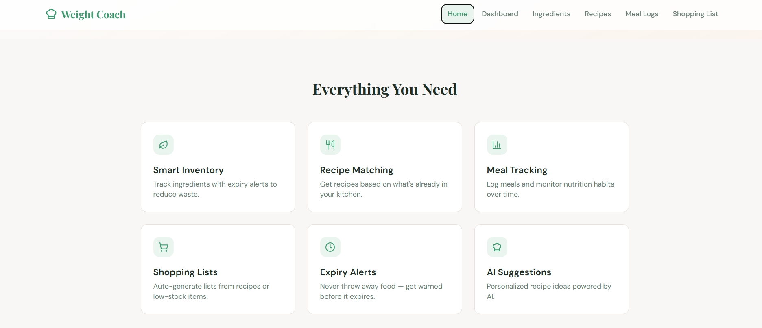
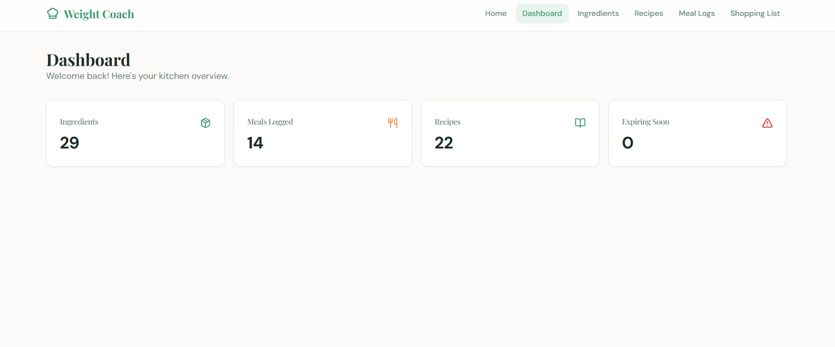
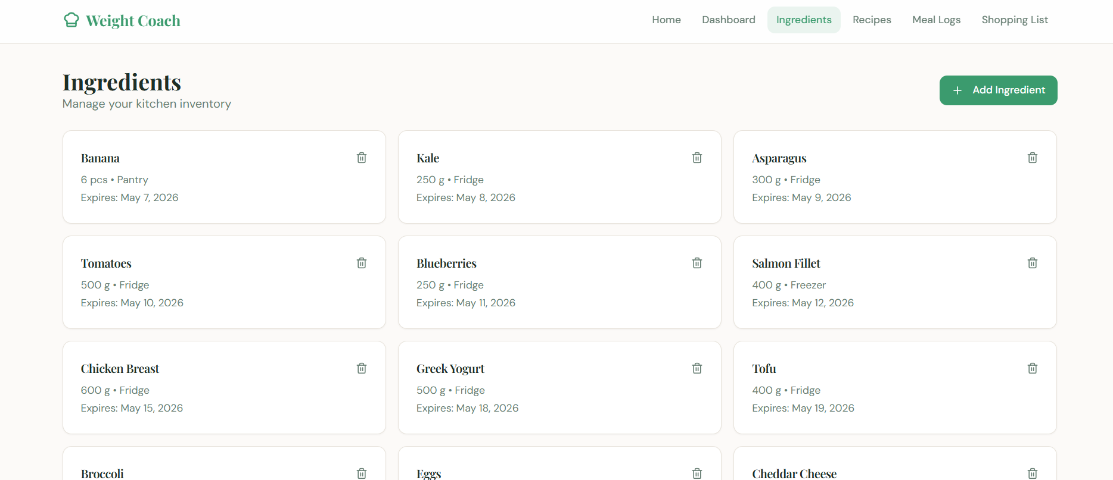

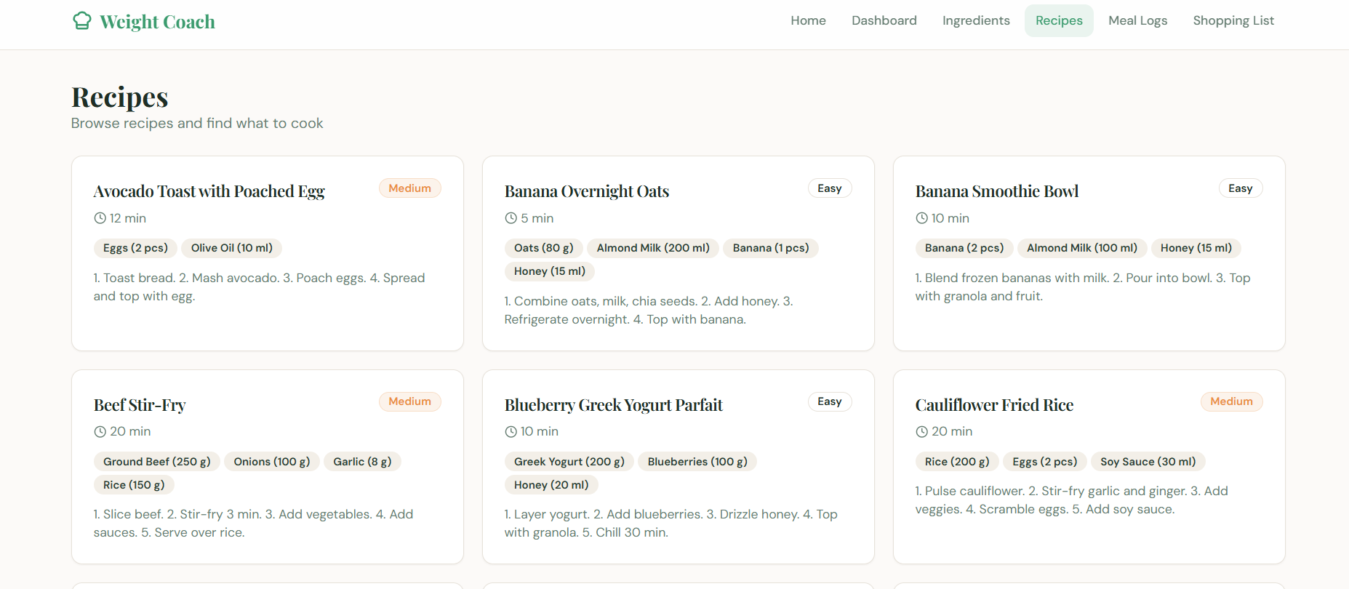

7.2 Screenshots of Database





Chapter 8 — Conclusions

8.1 Project Summary
The Weight Coach App is a full-stack database-driven web application designed to help users manage their dietary habits, track ingredient inventories, log meals, and receive personalized recipe recommendations. The project was developed as part of the 21CSC205P Database Management Systems course and demonstrates practical application of relational database design principles on a real-world health and nutrition domain.

The system was built using MySQL as the backend relational database management system and implements advanced concepts including normalization up to the Fifth Normal Form (5NF), stored procedures, triggers, views, and referential integrity constraints. The frontend interfaces with the database to provide an intuitive experience for tracking calories, managing ingredient expiry, and discovering recipes that match user dietary preferences.

8.2 Key Achievements
- Successfully designed and implemented a normalized relational schema spanning over 10 tables, achieving 5NF to eliminate all redundancy and join dependencies.
- Built automated triggers to enforce business rules — blocking insertion of expired ingredients and auto-assigning default ratings on meal log entries.
- Created database views (expiring_ingredients_view, recipe_details_view, user_meal_summary_view) that simplify complex queries for the frontend.
- Implemented a comprehensive recipe recommendation system driven by user dietary category preferences stored in a separate junction table.
- Applied referential integrity through foreign key constraints with cascading behaviour, ensuring data consistency across all related entities.
- Demonstrated a practical use-case of health technology by combining nutritional data, user preferences, and ingredient tracking in a single unified schema.

8.3 Limitations
While the system accomplishes its intended goals, certain limitations were identified during development and testing. The current implementation does not incorporate a real-time calorie calculation engine tied to nutritional databases such as USDA FoodData Central. Additionally, the recipe recommendation logic relies solely on category tag matching and does not leverage collaborative filtering or machine learning techniques that modern dietary apps employ. The scope of the front-end was limited to demonstrating database connectivity rather than delivering a production-ready user experience with authentication, session management, and responsive design.

8.4 Future Scope
- Integration with external nutrition APIs (e.g., Open Food Facts, USDA FoodData Central) to enrich the ingredient database with calorie and macro-nutrient data automatically.
- Implementation of a machine-learning-based recommendation engine trained on historical meal logs and user ratings to suggest personalized recipes.
- Addition of a social features layer allowing users to share meal plans and recipes, consistent with Web 2.0 health coaching patterns.
- Mobile application development (React Native / Flutter) with push notifications for ingredient expiry alerts and meal reminders.
- Deployment to a cloud-hosted MySQL instance (AWS RDS or Google Cloud SQL) with role-based access control for multi-user scalability.

